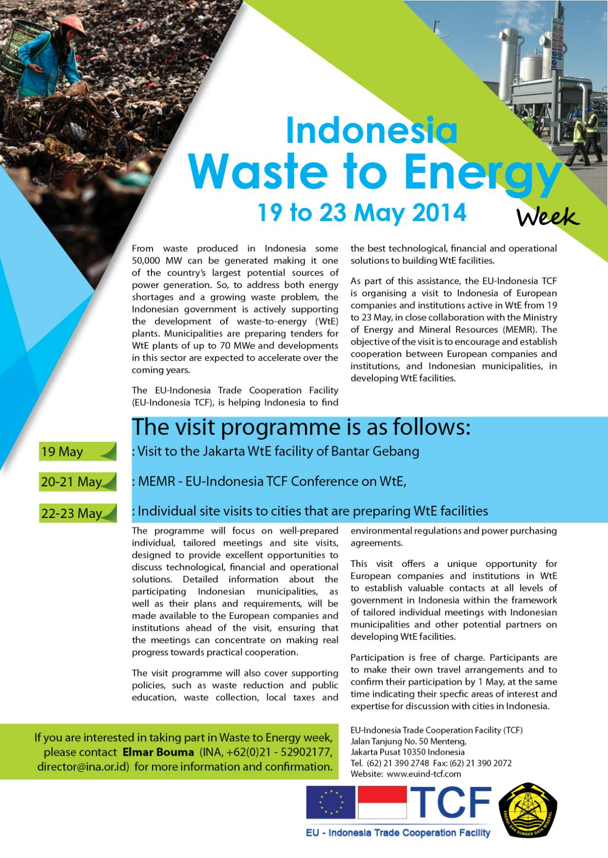

Detailed Program

TIME | AGENDA
Monday, 19 May 2014
09:00 - 10:00 | Delegation Reception, overview of the WtE Week by MEMR  The European delegation will be received by the Ministry of MEMR in the hotel or at the Ministry, to obtain a first over- view of WtE development in Indonesia and of the program for the week.
11:30 - 14:00 | Visit to Bantar Gebang  The European delegation will be taken to the Bantar Gebang landfill, which handles the waste from Jakarta and has one WtE installation operational. The objective is to obtain a direct look at the issues in waste-management and WtE. MEMR will the make visit arrangements with the Landfill and WtE facility management.
19:00 | Flight to Yogyakarta
Tuesday, 20 May 2014
09:00 - 16:30 | WtE Conference  The purpose of the WtE Conference is to discuss regulatory and policy issues as well as technological and financing solutions for WtE projects. Selected municipalities will be able to present their plans on dealing with WtE.  The EU Associations and EU firms will comment and offer assistance through collaboration on feasibility studies, educational programs, local regulations (for example explain how they receive payments from glass producers, clothing industry, and how this was negotiated).  Invitees :  • 10 regency governments (Only regencies who are providing basic information about their WtE plans will be invited. Also, regencies may submit more detailed information and questions in order to be discussed in a focus group meeting. For both, a questionnaire will be provided by the TCF Team  • European and Indonesian technology providers, operations companies, financing institutions;  • Selected European municipal authorities and representatives from the European Union.
09:00 - 09:30 | Plenary Opening  • HE Olof Skoog - EU Ambassador *  • Jero Wacik – Minister for Energy and Mineral Resources or Director-General *  • Sri Sultan Hamengku Buwono X – Sultan and Governor of Yogyakarta *
09:30 - 12:00 | Presentations  • Dadan Kusdiana, Director for Bio-Energy MEMR  • Loek Bergman, WTE Policy Specialist *  • Antonie de Wilde, Team Leader EU-Indonesia TCF  • Indonesian Regency (Yogyakarta, Batam)  • Fabby Tumiwa – IESR expert  • Mr Pierre Tournier, Managing Director, Waste-To-Energy Facility Savoie Déchets
13.30 - 16.30 | Presentations  • Ministry of Public Works, Pak Djoko Mursito*  • Bappenas, Pak Bestari*  • Ministry of Environment, Pak Sudirman*  • Indonesian Municipalities  • European company/ies  • PLN*
Wednesday, 21 May 2014
09:00 - 16:10 | Focus Group Meetings: Individual Regency - Companies  Parallel meetings of one regency government and technology providers (TP), financing institutions (such as SMI, KfW, DEG, AFD, IFC, banks) (FI) and operational companies (OC), to discuss possible project set-ups.
16:30 - 17:00 | Plenary Closing  All Day in Lobby Area: Information Booths of Technology providers and Operational companies
Thursday, 22 May and Friday, 23 May 2014
22 May | Site Visits  European companies or municipalities will also be offered the possibility for a second site visit further away. (f.i. DIY, Batam, Palu)
23 May | De-briefing  On the afternoon of the last day of the visit, the European companies or municipalities will convene again in Jakarta with the Ministry of Energy and Mines, to report about their findings and intended follow-up actions.
*To be confirmed
Office:
Jalan Tanjung No. 50 Menteng,
Jakarta Pusat 10350 Indonesia
T. (62) 21 390 2748 F. (62) 21 390 2072
W. www.euind-tcf.com
W. www.wteindonesia.com

Further information please contacts: Elmar Bouma (INA, +62(0)21 - 52902177, director @ina.or.id)

O Yes, I am interested to participate in the Waste-to-Energy Week, 19 – 23 May 2014
Kindly use the format below for providing us with the information on your company, as much as possible (max 100 words per item).
Company Name
Address
Contact person
- Email address
- Mobile Phone number
Short company profile (size, products and services, summary list of relevant projects)
International Certifications
Solutions offered to Indonesian regencies in developing waste-to-energy installations
Range of energy generating capacities (in MW)
Technology type(s)
(incineration, gasification, pyrolysis, others) and value generated (electricity, oil, organic matter, etc)
Main advantages of technology/ies offered (robustness, yield, flexibility, investment etc)
Constraints and other issues to be discussed with regencies
Participation and/or (co-)financing possibilities by the company
Regencies you are particularly interested to meet on 20 and 21 May or visit on 22 and 23 May | Meet (20 and 21 May):
 | Visit (22 and 23 May):
Do you wish to participate in the site visit to Bantar Gebang on 19 May ? | O Yes O No
Do you object if we put your company profile on the website www.wteindonesia.com ? | O No objection O Object  O I can email a company presentation (max 5 MB) to put on the website
I would like to have a table to display materials. | O Yes O No
Please return this form to : Elmar Bouma, ina@ina.or.id, or fax : (+62-)(0)21-52902178

