expansion project for TPP-4 CAPACITY
by Т-120/130-130-8мо type turbine

Tseveen.B – TPP-4 Executive Director, Consulting Engineer and Doctoral Candidate
Purevdorj.G- MEA Secretary-General, Doctor, Professor
Batchuluun.D – TPP-4 Senior Engineer and Consulting Engineer

SUMMARY: It is assumed that there is opportunity to make contribution to supply the rapidly increasing demand of Central Energy System and Ulaanbaatar District Heating System in following years by installing new Т-100-130 type heating turbine in the TPP-4.

1. introduction of tpp-4
Thermal power plan No.4 construction work was commenced in 1979. The first unit was put into operation in 1983 and the first stage, with 380MW project capacity, was put into operation in 1987. As a result of the energy growth, there were made the further capacity expansions such as 160MW in 1988-1990 and 2 x 20MW in 2007 and 2009 respectively. At this time, TPP-4 has an installed power generation capacity of 580MWe and heat generation capacity of 1185Gcal/hour (1378MW).
The plant supplies 70% of total electricity demand of Energy Sector of Mongolia, and 65% of district heat demand of Ulaanbaatar city.

Table -1 Engineering-And-Economical Performance of TPP#4
Performance \ Year |  |  | 1990 | 1995 | 2000 | 2005 | 2010 | 2011
Generated power |  | million.KW.hour | 2,018.9 | 1,654 | 1,909.6 | 2,260.8 | 2,940.5 | 3.101.5
Distributed power |  | million.KW.hour | 1,703.2 | 1,314.9 | 1,525.6 | 1,889.1 | 2,533.5 | 2.690.8
Distributed heat |  | thousand.Gcal | 2,036.6 | 2,147.9 | 2,523.1 | 2,783.6 | 3,106.5 | 3.128.8
 |  | million.KW.hour | 2,368.6 | 2,498.0 | 2,934.3 | 3,162.1 | 3,612.8
Auxiliary power |  | % | 15.6 | 20.5 | 19.25 | 16.44 | 13.84 | 13.24
Specific fuel consumption | Power | gr/ KW.hour | 332.17 | 416.85 | 388.93 | 349.47 | 305.053
 | Heat | kg/ Gcal | 180.67 | 187.73 | 184.12 | 180.396 | 174.315
Power, generated by heating condition |  | % | 38.7 | 44 | 52.14 | 42.67 | 31.05 | 30.37
Boiler capacity utilization |  | % | 36.9 | 31.7 | 36.04 | 41.73 | 49.32 | 50.22
Turbine capacity utilization | Power | % | 50.1 | 34.9 | 40.2 | 48.06 | 65.57
 | Heat | % | 26.8 | 21.8 | 28.94 | 33.65 | 31.15
Turbine average load |  | MW | 230.4 | 188.8 | 217.4 | 259.51 | 335.68 | 354.06
Boiler average load |  | tonn/hour | 340 | 323 | 338 | 336 | 348 | 351
The operated boiler number |  | number | 3.19 | 3.3 | 3.59 | 4.18 | 4.76 | 4.8
The operated turbine number |  | number | 3.22 | 3.07 | 3.27 | 3.8 | 4.58 | 4.57
Coal consumption |  | thousand.tonn | 1,937.3 | 2,007 | 2,197.9 | 2,503.9 | 2,880.0 | 2.899.7

Table-2 Energy production growth of TPP-4 in last 5 years
Performance \ Year |  | 2007 | 2008 | 2009 | 2010 | 2011 | 2012 | increase
Generated power | million.KW.hour | 2,486.0 | 2,694.4 | 2,711.3 | 2,940.5 | 3,076.0 | 3,171.4 | 5.0
Produced heat | thousand.Gcal | 2,873.1 | 2,942.3 | 3,052.6 | 3,052.6 | 3,106.5 | 3,107.1 | 1.9
 | million.KW.hour | 3,341.4 | 3,421.8 | 3,550.1 | 3,550.1 | 3,612.8 | 3,613.5

TPP-2
TPP-3
DTPP
ETPP
TPP-4

Figure -1: Load demand curve of CES as of 25 December, 2011
TPP-4 peak load was 582 MW at this day.

2. Requirement for tpp24 capacity expansion
CES have been installed no single new generating facility since installation of TPP#4 within 20 years. But we have expanded our plant capacity by 40MW and CES capacity is 794.3MW as of today. The installed capacity utilization of CES were minimum of 283.7MW (36.8%) in 1995. Then it increased gradually and reached to 471.1MW (59.3%) in 2010. The average annual installed capacity utilization of CES was 88.8% during 2010-2011 winter peak demand. Average annual installed capacity utilization of other CES’s TPPs was 78.8-86.3% and average annual installed capacity utilization of TPP-4 was 70.1%.
In 2011, the generated power of CES was 4,313.8 million KW.hour and the distributed power of TPPS was 3,660.6 million KW.hour. This distributed power increased from 2010 by 178.1 million KW.hour or 5.1%. Also the distributed heat of TPPs comprising CES was 6,116.1 thousand.Gcal (7,113 million.KW.hour) in 2011. It is increased by 97.9 thousand.Gcal or 1.6 % compared to 2010.
CES cannot already supply the peak load of National Transmission Grid. There is a problem that not be supplied even imported from Russia. As a result of researcher, MMRE and EA assumptions and the feasibility study of TPP5, CES electricity demand and peak load will be increased greatly in the near future.
On the other hand, on 2010, the Parliament issued Resolution No.72 on Actions to Be Taken on Fuel and Energy Sectors is stated that Ulaanbaatar power and heat demand growth shall be supplied by expanding the installed capacity of TPP3 and TPP4. In accordance with this resolution, some study and actions are commenced.
On the basis of power and heat forecast including statistic growth and new consumer, especially considering middle speed growth , preliminary study of project for TPP4 capacity expansion by new turbine is assumed that the electricity peak load and demand of National Transmission Grid will be 900-1600 MW and 5,600-8,900 million.KW.hour and the peak heat load of Ulaanbaatar will be increase 343 Gcal/hour in 2015.

Figure -2: Power demand forecast of CES in 2010-2030
а) New consumer included estimation; б) By statistic growth

Figure-3: Power load forecast of CES in 2010-2030
а) New consumer included estimation; б) By statistic growth
TPPs are connected to the heat supply line according to the selected variant which is assumed as most suitable hydraulic conditions of Ulaanbaatar centralized heat supply system. Connections between heat recourses and consumers are shown in Figure-4.

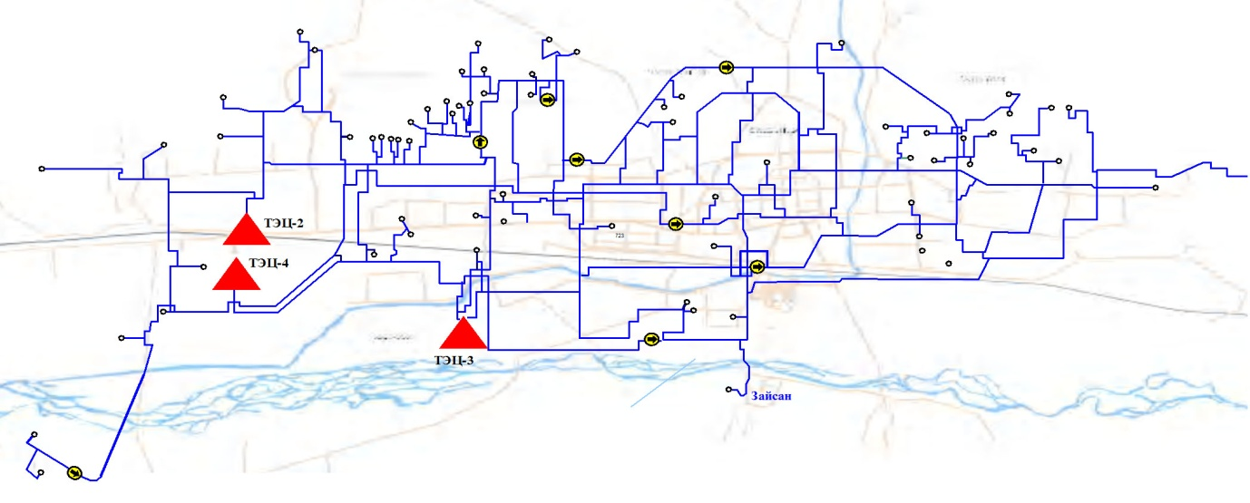

Figure -4. Consumer scope of TPPs
Notation: The area circled by straight line is supplied from TPP4.
Table-3: The installed capacity of Ulaanbaatar TPPs heating equipment
Plant | Heat ¹ |  | In line | Boiler |  | Deaerator | Make up water | Chemical water
 | Steam, t/h | Water, Gcal/ц | t/h | ҮБ, t/h | ТБ, t/h | t/h | t/h | t/h
TPP-2 | 55 | 57 | 800 | 800 | 800 | 100 | 40 | 100
TPP-3 middle pressure | 275-75² | 567 | 3,000 | 3,750 | 2,500 | 100-20¹ | 90 | 80
TPP-3 high pressure |  |  | 5,000 | 3,750 | 3,750 | 300-140² | 200 | 120
TPP-4 | 100 | 1,059 | 9,900 | 17,400³ | 14,400⁴ | 800 | 600 | 600
Total : | 430-75 | 1,683 | 18,700 | 18,300 | 17,050 | 1300-160 | 930 | 900
¹-Схема теплоснабжения г.Улан-Батора до 2000 года. ВНИПИЭНЕРГОПРОМ Москва 1988 г.
²-actual capacity
³-ПСГ-(2300х3ПТ+3500x3Т)=17400 t/h
⁴-ПСВ-500х8=1800х8=14400 t/h

Table -5: Heat load of TPPs during 2011/2012 heating season
Plant | Estimated in 2011/2012 heating season condition |  |  |  | As of January ,2012
 | Steam, t/h | Water, Gcal/ц | Comsumption t/h | Make up water, t/h | Steam, t/h | Water, Гкал/ц | Comsumption, t/h | Make up water, t/h
TPP-2 | - | 60 | 750 | 20 | +55 | -3 | +50 | +20
TPP-3 middle pressure | 40 | 248 | 3,100 | 90 | +160 | -1 | -100 | -10
TPP-3 high pressure |  | 320 | 4,000 | 140 |  | -1 | +1000 | +20¹
TPP-4 | 30 | 990 | 10,000 | 460 | +70 | +69 | -1000 | +140
Total : | 70 | 1618 | 17,850 | 710 | +285 | +65 | -50 | +170

In the project, the heat capacity of TPP5 is considered on 2020 load level. Two stage developments for TPP5 are selected and first stage will be implemented in 2015 and second stage will be 2020. It assumed that the heat capacity of TPP5 will be 453 Gcal/hour in 2015 and 1101 Gcal/hour. According to the feasibility study, TPPs and the consumers’ connection to heating system after TPP5 fully put into operation is shown in Figure 5.
The heat supply of Ulaanbaatar western side and “New Yarmag” district will be supplied by TPP4 installed capacity increasing until TPP5 installation. The previous duty of TPP4 will remain until TPP5.

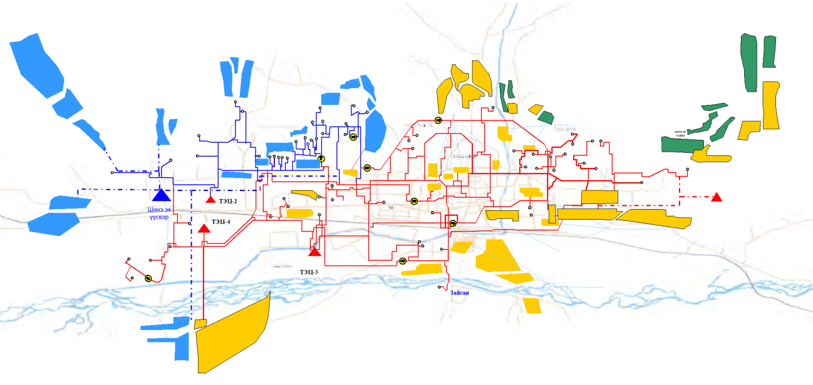

Figure-5. TPP4 and TPP5 working scope in Ulaanbaatar heating system

3. capability and result of tpp4 capacity expansion
The plant design was made on the assumption that to make a plant expansion several times.
Table -6: TPP4 main design specifications
 | Unit | Specification | (Expansion)
 |  | I stage | Total capaicity
1. Power output | MW | 410/460 | (160/200)  570/660
2. Heat output | Gcal/hour /MW/ | 1028  /1196/ | 317  1347
3. Main equipment configuration:
Boiler | number | БКЗ-420-140-10С -6 ш | (БКЗ-420-140-10С -2 ш)  БКЗ-420-140-10С -8 ш
- Unit output | tonn/hour | 420 | 420
Turbine | number | ПТ-80-130 -1ш  Т-110/120-130-5 -3ш | (ПТ-80-130 -2ш)
ПТ-80-130 -3ш
Т-110/120-130-5 -3ш
- Unit output | MW | 80/100  110/120 | 80/100  110/120
Generator | number | ТВФ-120 -4ш
- Unit output | MW | 120 | 120
4. Auxiliary power | % | 13.56 | 13.56
- For heat | % | 7.8 | 7.71
5. Installed capacity utilization | hour/year | 5230/4660 | 5108/4412
6. Power distribution in year | Million KW⋅hour | 1853 | 2504
7. Heat distribution in year | Million Gcal | 3973 | 4856
8. Fuel consumption | Million tonn specific fuel /year | 1.05 | 1.325
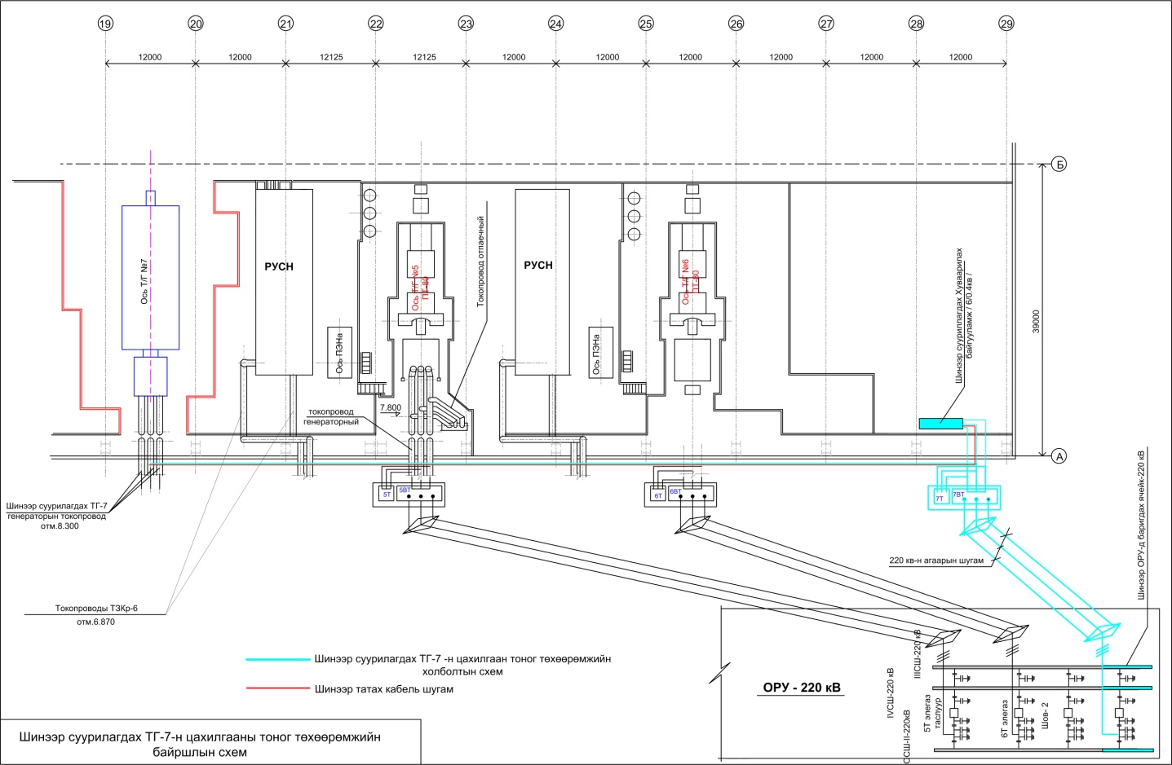
Currently, the plant his working with its full design capacity. Its capacity exceeds every year after 2007 especially the power of 500 million KW.hour was generated over the installed capacity in 2010 and 2011 respectively. Today auxiliary power is in project value, specific fuel consumption for power is 305,053 gr/kW.hour and for heat is 174,315kg/Gcal and the installed capacity utilization for power is 65,57%, and for heat is 31,15%.Since new energy recourse is necessary to supply of power demand of CES the near future, our plant staff is working to contribute to this issue. Our staff has made TPP4 capacity expansion study with MEA consultant scientist and determined that there great possible to install additional Т-100-130 type heating turbine. 1. The plant will not use the area between turbine 4 and 5 where located the evaporation equipment introducing new water treatment technology (reverse osmosis). This area will be the site of new turbine.
Зураг-4: “ДЦС-4” ТӨХК-ийн шинээр турбин суурилуулах байршил

2. Following scheme modification and turbine equipment connction shall be made to new turbine installation.
- Recirculation water scheme including 6 modifications of related scheme
- Modification of heating system water scheme
- Modification of main condensate scheme of deaerator
- To provide steam from steam collector to new turbine main ejector
- Modification of feed water pump packing condensate scheme
- Steam line connection modification of turbine 4 and 7
- Modification of feed water connection scheme of turbine 4 and 7
- Scheme for new turbine packing steam to be supplied from steam balancer
3. The preliminary economical analysis of TPP4 capacity expansion project has been undertaken on basis of the following main data:
- Technical- economical performance of TPP4;
- Discount rate is selected as average inflation in 2000-2012;
- TPP4 investment - 1,200,000 US$/MW
- 35% of total investment – Building
- 5% of total investment – Equipment and pipeline
- 3.5% of total investment – Heat and electrical assembly
- 37% of total investment – Construction work
- 19.5% of total investment – Main equipment

Considering several resources such as own fund, state investment and bank loan, the loan and accumulation rate has been taken as average 6%.
Since there are not required the investments for the building, cooling tower and boiler, the unit capacity investment can be low. Based on these, the preliminary investment estimation of TPP4 capacity expansion project has been undertaken and calculated the discount and integral value of the net profit.

Net profit discount value
Net profit integral value
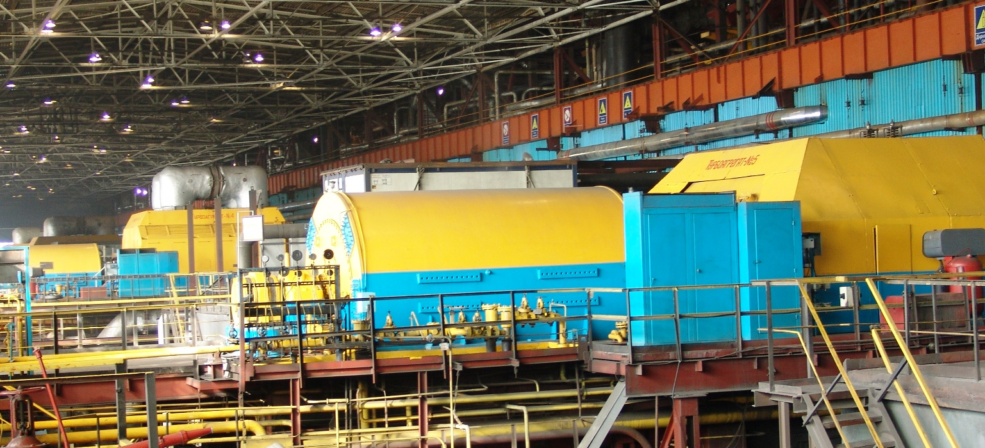
Note: Plant expansion investment has been estimated with maximum version.
Figure -6: The discount and integral value of TPP4 capacity expansion project net profit

preliminary proposol and summary of project benefit
- The general assessment has been made for capacity expansion project possibility to supply the increasing power demand and whether the project has economic benefit. This project had benefit since E<E_{вн} (9.7 %< 12%) when compared the investment discount rate E and the internal profit rate E_{вн}.
- Return full cost recovery period of project is 7.8 years.
- Profitability (profitability index) and profit rate are coherence with net cash flow and if it assumed that the project will be implemented when Э_{инт}>0 and А_{И}<1:
А_{И}
Since А_{И}=0.12<1, the project has met with this criterion.
- Implementing the expansion project, plant will supply the increasing demand until 2017. The plant will be having significant impact on Ulaanbaatar heating demand in the further.
- The plant power price will be 40-60 tug/kW⋅hour for long time. It has a good influence for vulnerable group consumers to protect from power price growth.
- It is assumed that TPP4 capacity expansion project will be commenced in the end of 2012 and completed before 2014 winter peak demand.

Preliminary result

