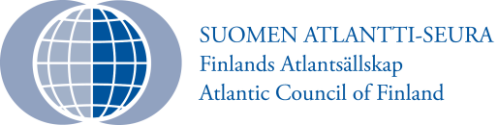
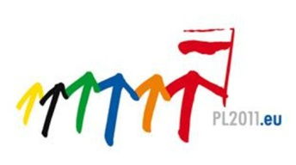

„EMPOWERING EURO-ATLANTIC SECURITY-
Please confirm your participation until 14 October 2011.
magdalena.asikainen@msz.gov.pl
Tel. 0 503 293 567

The meeting will be held in English

On the occasion of the Polish Presidency
of the EU Council
Embassy of the Republic of Poland
&
Atlantic Council of Finland
request the pleasure of your company
at the Conference
„Empowering Euro-Atlantic Security:
New Challenges, Threats and Opportunities”
on Monday, 17 October 2011 at 14.00-20.00
in Wanha Satama, address: Kanavakatu 5, Helsinki
NEW CHALLENGES, THREATS AND OPPORTUNITIES”
Wanha Satama, Helsinki, October 17, 2011

14.00-14.10 Welcoming remarks
H.E. Mr Janusz Niesyto, Ambassador of Poland, Embassy of the
Republic of Poland in Helsinki
Mrs Liisa Jaakonsaari, Member of the European Parliament, Chair of the Atlantic Council of Finland

14.10-15.40 SESSION I: DEVELOPMENT OF EU’s COMMON SECURITY AND DEFENCE POLICY: EU-NATO
CO-OPERATION

CHAIR: Mrs Liisa Jaakonsaari, Member of the European Parliament, Chair of the Atlantic Council of Finland

- Common Security and Defence Policy as a guarantor of the EU integrity
- Future development of the EU battle groups
- Pooling and sharing initiative in the EU’s Common Security and Defence policy development
- EU-NATO cooperation – Common operations?

Speakers:
- Mr Ryszard Demczuk, Vice admiral, Deputy Comm. Joint Anti-Corruption Task Force, NATO HQ, Kabul (until Aug. 2011 r.)
- Mr Rastislav Káčer, President of the Slovak Atlantic Council, former Secretary of State in the Ministry of Defence
- Mr Sven Mikser, Member of the Estonian Parliament, Leader of the Social Democratic Party (SDE) in Estonia, Chairman of the Estonian Atlantic Treaty Association, Former Minister of Defence of Estonia
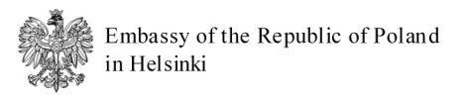
- Dr Teija Tiilikainen, Director, The Finnish Institute of International Affairs

15.40-16.00 Coffee

16.00-16.45 Keynote speech

- Dr Erkki Tuomioja, Minister for Foreign Affairs of Finland

16.45-18.15 SESSION II: NATO-RUSSIA: EURO-ATLANTIC SECURITY COMMUNITY?

CHAIR: Professor Adam D. Rotfeld – Former Minister of Foreign Affairs
of Poland

- NATO – Russia Partnership after Lisbon Summit
- In search for new rules, goals and principles
- How to reconcile the fears and hopes of the West and Russia?
- European security – in search for place for Russia

Speakers:
- Dr Tuomas Forsberg, Professor, University of Tampere
- Mr Petr Kolar, Ambassador of the Czech Republic to Russia, former Deputy Minister of Foreign Affairs
- Dr Jerzy M. Nowak, Vice-Chair of the Polish Euro-Atlantic Association, former Permanent Representative of Poland to NATO
- Mr Robert Pszczel, Director of NATO Information Office in Moscow
- Mr Pertti Salolainen, Minister (Hon.), Vice-Chair of the Foreign Affairs Committee in Parliament of Finland, Vice-Chair of the Atlantic Council of Finland

18.15-18.20 Closing remarks

18.20-20.00 Cocktails

Embassy of the Slovak Republic in Helsinki

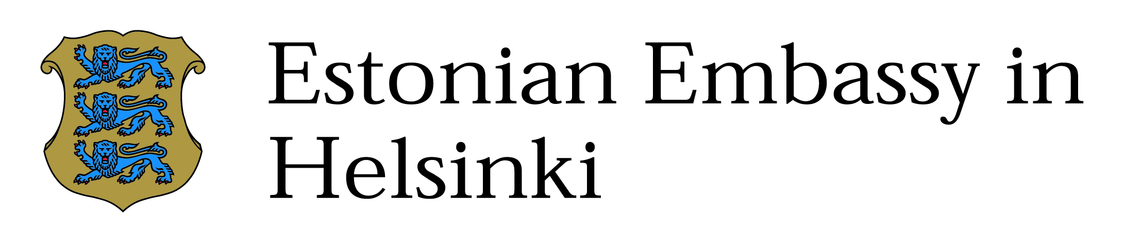

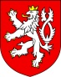
Embassy of the Czech Republic
in Helsinki

