

**Photo**

**Essay**

**Report**

Strengthening and Developing of Civil Society and Political Parties (Capacity Building Project)

*May 24th – 25th 2012*

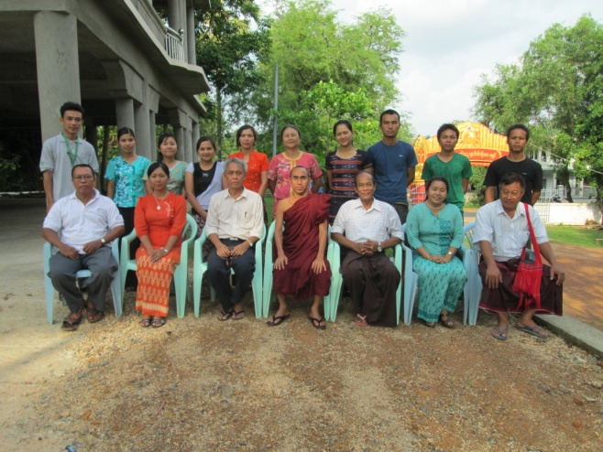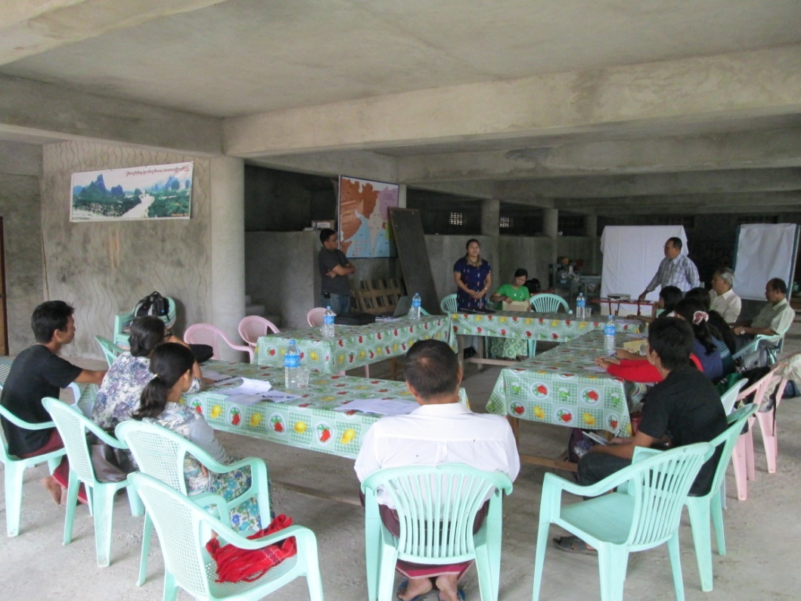

Prepared by

**Saw Eh Moo**

Project Manager

**Date 06.06.2012**

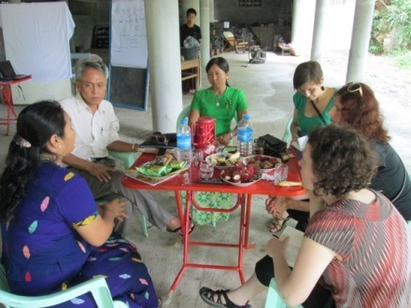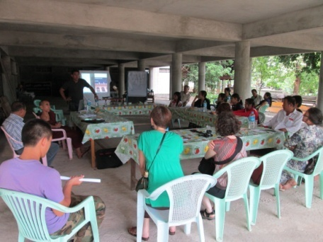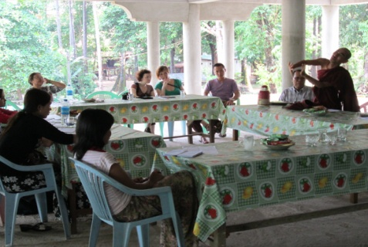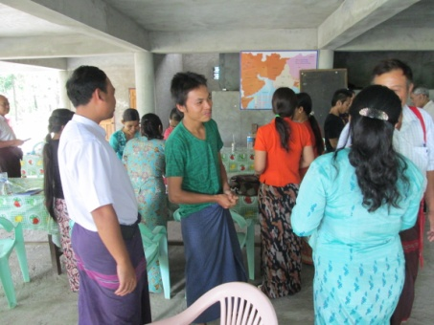



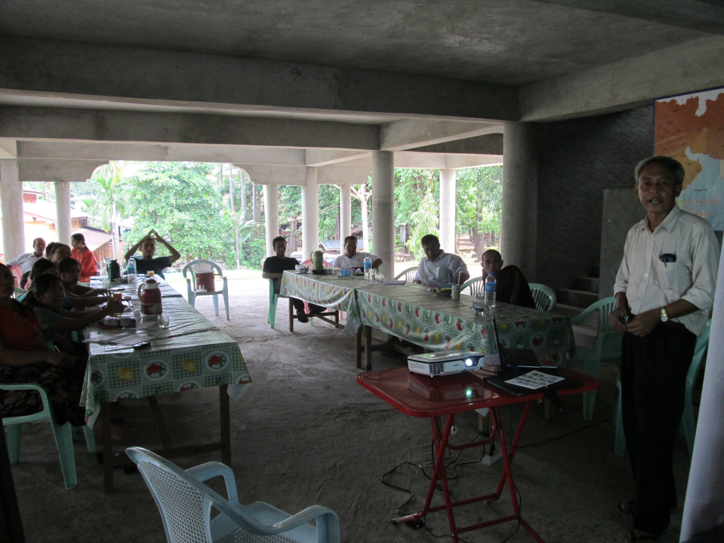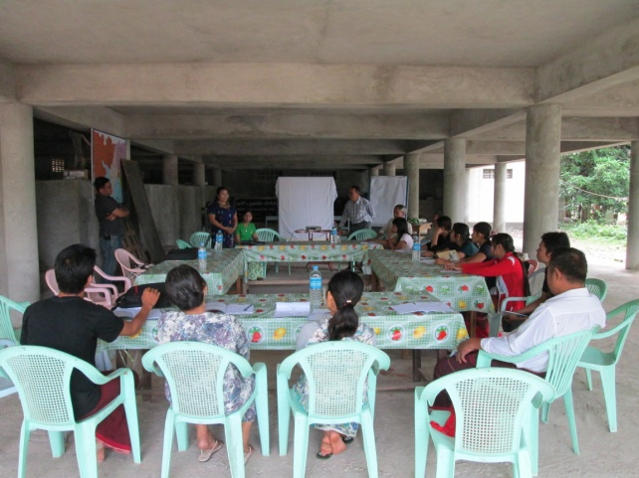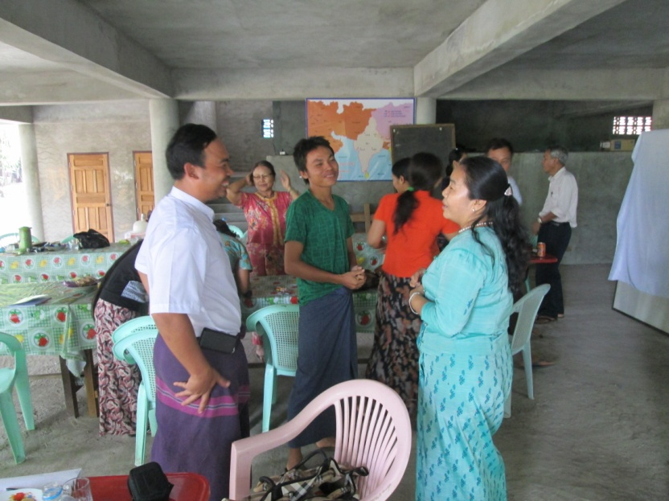rr;

Sharing information about present situation and what are the difference between Kachin State and Kayin State. (KDP Chair (Kayin Party) and NDF Chari from Kachin state

Getting to know each other/introduction to each other before starting the Human Right Training

**Page 2**

Photo credits:

**Senior Project Officer**

Lecturing about Human Right and its processes by Dr. Khin Zaw Win

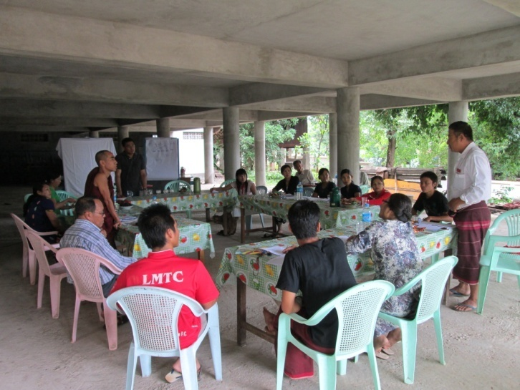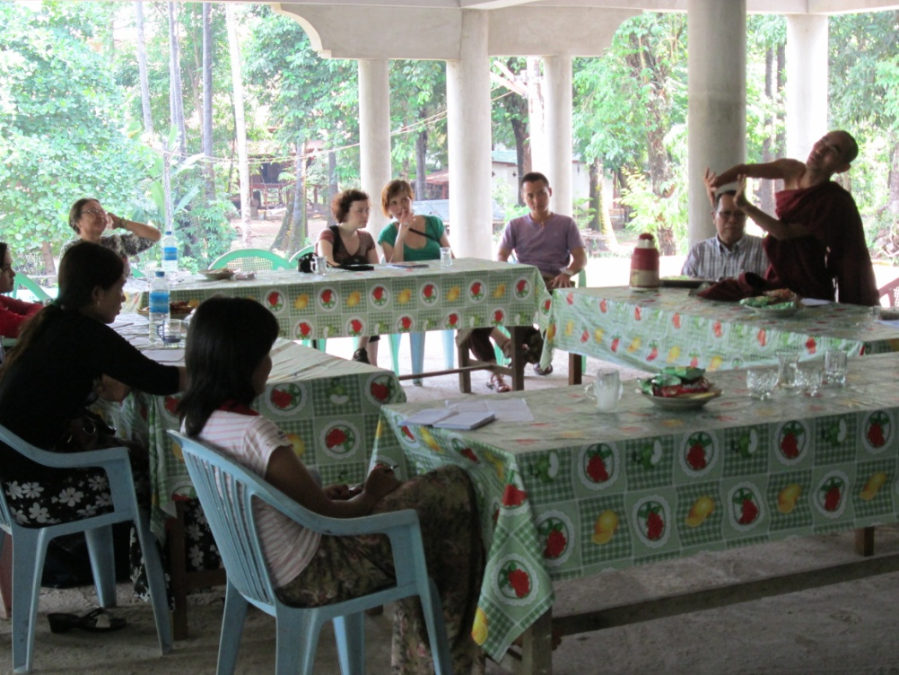

Presenting about current Economic Situation in Karen State

Giving information about Human Right and the right in Myanmar by U Tin Myint (Lawyer)

**Page 3**

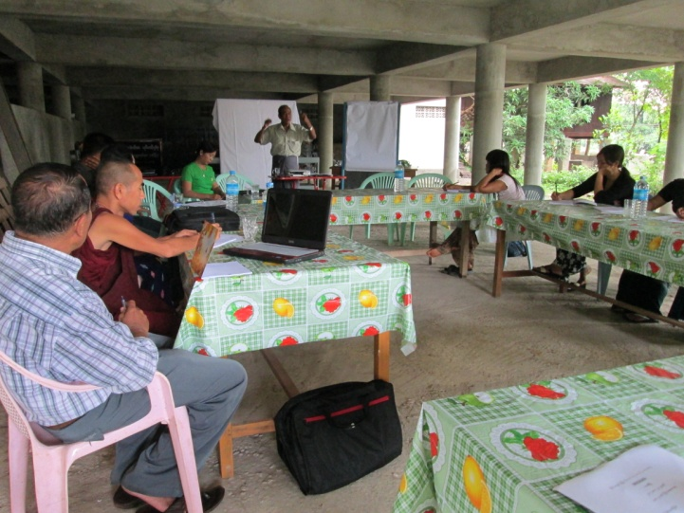

Buddhist Monk is presenting about the behavior and attitude of Karen People and their nature.

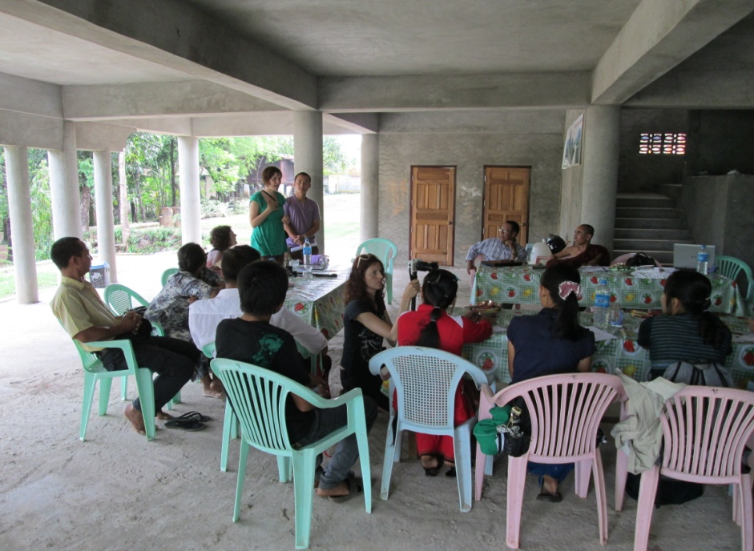

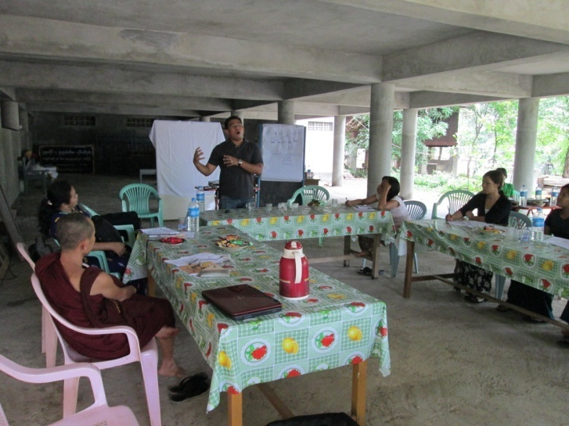

Ms. Monika (ADRA Czech) introducing about herself to the training participant and talking about the project activities and plan for the development of Karen State as well as plan to support to Kachin State.



Presenting about international or

World finance organizations on recent

Time

Photo credits:

**Senior Project Offier**

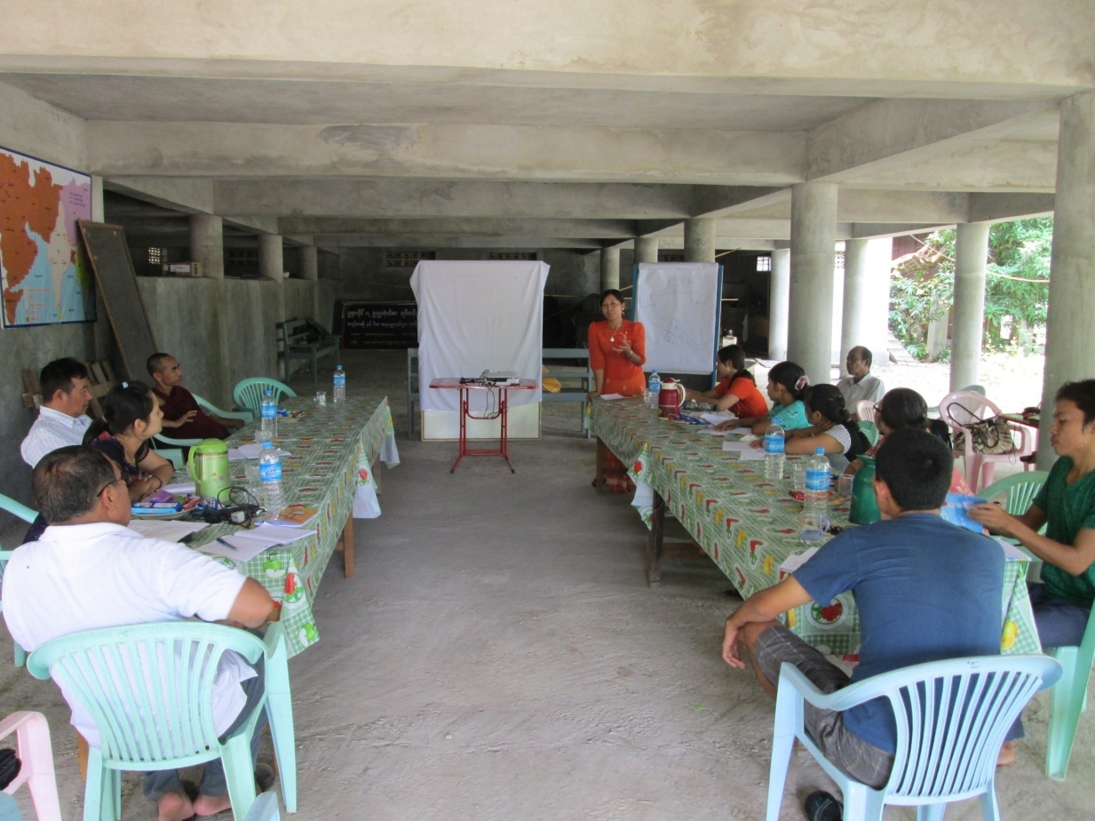

Presenting about Party Development and to improve on mobilizing and organizing by Daw Aye Thandar.

Giving encouragement speech to the Training Participants and talking about different kind of leadership style and characteristic of a good leadership by Saw Caleb (Networking and Training Coordinator from ADRA Kayin Project)

One of the CHWs explain the patient how to take the medicine.

**Page 4**

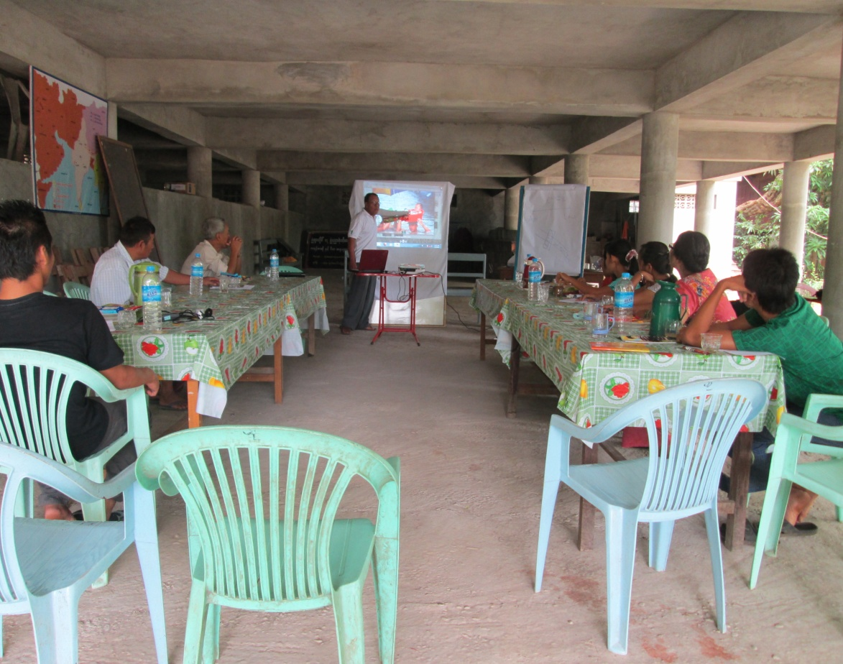





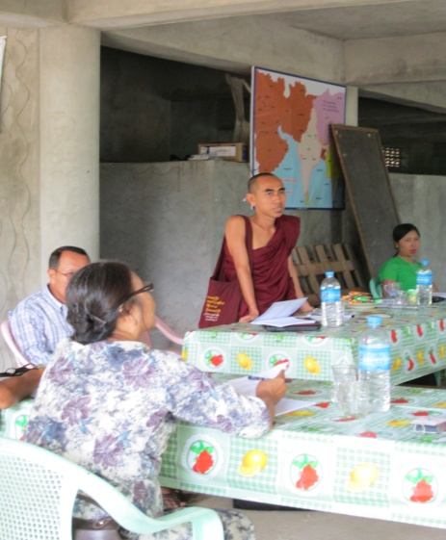



Photo credits:

**Senior Project Officer**

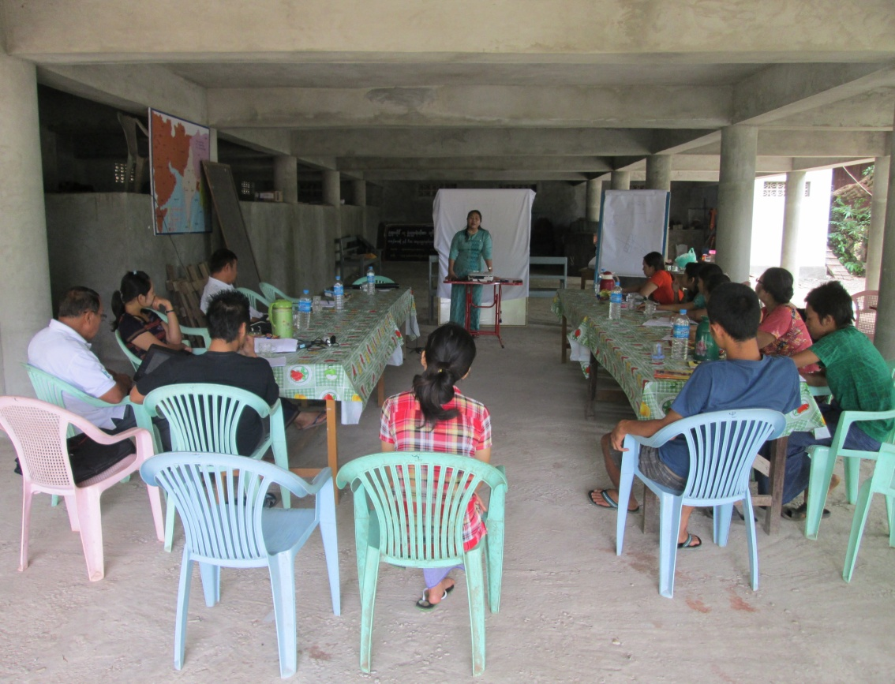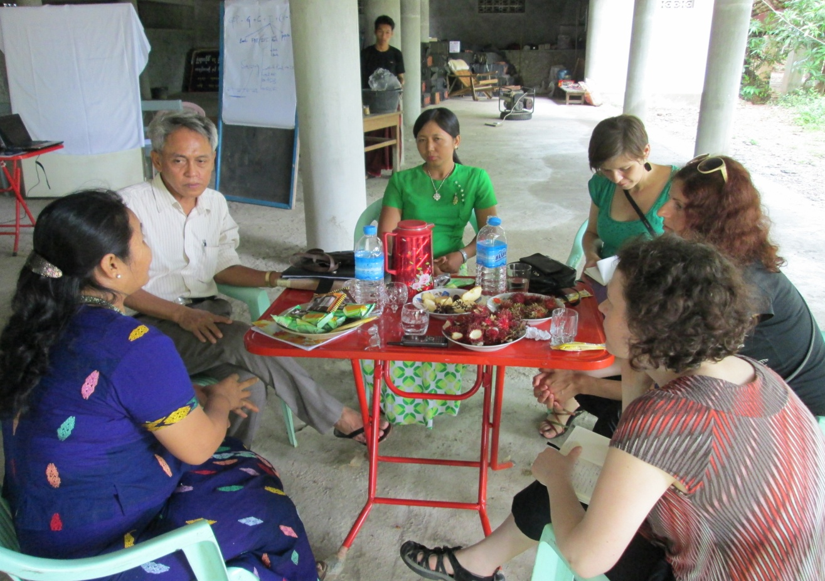

Meeting with Trainers during the break time on Human Right Training at Hpa-an

Daw Bout Jar from Kachin State sharing the information on the current situation in Kachin State and the war between KIO and the Military. Mentioned about how minority of ethnic groups are suffering from the Military Government.

because of poor personal ygie.

**Page 5**



Changing the world one life at a time

**Room A 3-2, 4th Floor, E-Condo, North Bazaar Road, Dagon Tsp, Yangon Myanmar**

**Tel. 01-240.900, 01-380.419**

**www.adramyanmar.org**