 | Ministerstvo zahraničních věcí České republiky | Ministry of Foreign Affairs  of the Czech Republic

Project evaluation report
Czech Development Cooperation of the Czech Republic

Comprehensive Education of Teachers in Global Development Education (La Ngonpo II.)
Komplexní vzdělávání pedagogů v GRV (La Ngonpo II)
16/2012/14, 16/2013/14, 16/2014/14

October 2015
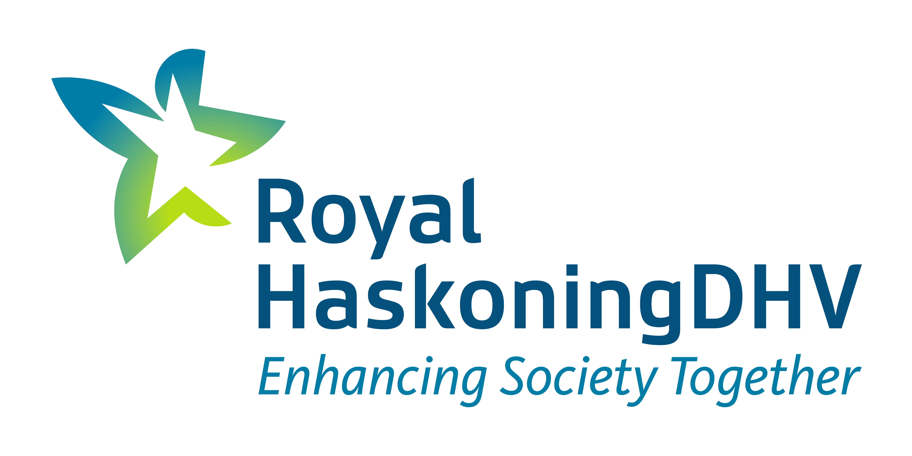

Evaluation team of HaskoningDHV Czech Republic, spol. s r.o.

Mgr. Lenka Brown
Mgr. Miroslava Drahotová

Executive Summary

Czech Development Agency annually announces grant selection procedure for the grant program "Global development education and awareness" to support projects in the field of international development cooperation submitted by non-profit organizations and other eligible entities. Until 2010 Ministry of Foreign Affairs was the promoter of this grant program.

This evaluation has been awarded by MFA and secured by the evaluation team of the company HaskoningDHV CR, Ltd. under the direction of Mgr. Lenka Brown and further the evaluator Mgr. Miroslava Drahotová.

This evaluation was focused on a comprehensive evaluation of the project Comprehensive teacher education in Global Development Education - GDE (La Ngonpo II) implemented in the framework of international development cooperation in the field of global development education in the Czech Republic in years 2012-2014 by the Multicultural Center Prague. The total financial volume of the project was 2 297 380,- CZK, of which the subsidy was 1 800 000,- CZK.

The project aimed to strengthen the global development education in schools (through the utilization of a package of educational seminars on multicultural and global development education) and to raise awareness of development issues and countries, the Czech public (through reaching the general public via exhibitions, discussions, media promotion of outcomes of students from partner schools). It wanted to contribute to the deepening of awareness and a deeper interest on development issues.

The main purpose of this evaluation was to assess the basic evaluation criteria of the OECD-DAC, in particular the relevance, efficiency, effectiveness, sustainability and impact, but also the implementation of cross-cutting principles of Czech development cooperation, which are proper (democratic) governance, respect for the environment and climate and respect for human rights of the beneficiaries, including gender equality.

The specific objective of this particular evaluation was for the aforementioned multi-year project implemented under the auspices of CZDA in the years 2012 - 2014 to evaluate activities with an emphasis on their impact and sustainability, possibly to assess to what extent and under what conditions is it possible to carry out this evaluation. Another objective of the evaluation was independent evaluation of project compliance with the general principles, as established in the National Strategy of Global Development Education for the period 2011 - 2015. The evaluation also assessed the project in terms of their external presentation (visibility) in the Czech Republic.

Furthermore, the project was aimed at assessing the intervention logic of the evaluated project where it was detected that the Logframe was not updated during the implementation of multi-year project to reflect minor adjustments for certain activities (eg. the frequency of realized seminars, lectures, addition of new activities in 2013, 2014, addition of new target group in 2014).

Regarding the actual evaluation of basic evaluation criteria of this contract, i.e. relevance, efficiency, effectiveness, sustainability and impact assessment, the undertaken conclusions are following:

The relevance of the project Comprehensive Teacher Education in GDE (La Ngonpo II) has been assessed as rather high due to the fact that in terms of fulfilling the objectives of the National Strategy of GDE, the project activities can be considered relevant in terms of their content. The activities are also in line with the needs of educational staff, as demonstrated by the findings of the field surveys. Activities for pupils included in the final year of the project were deemed as less relevant.

The effectiveness of this project is assessed as rather high. The main reason for this assessment of the criteria of efficiency is the fact that expended funds are appropriate for the actually provided activities, although some of the activities of this project can already be partially self-financed.

Effectiveness of the project is assessed as rather high; in the context of the stated objectives of the development intervention the Multicultural Center Prague, c.a. through the project activities continuously managed to contribute to increasing the knowledge and skills of teachers in the area of GDE, strengthening mainstreaming of global issues in pupils education and raising public awareness of the topics. However, it cannot be unambiguously determined whether and to what extent have the overall quantified targets for the project been fulfilled, given the fact that despite minor changes to the activities undertaken each year and despite adding a completely new objective of the project in the third year, no adjustments of the project’s intervention logic were made to reflect these changes.

Regarding the sustainability, this evaluation criterion is assessed as rather high. Part of the activities can be considered as self-financing - in particular continuing to work with the methodology of La Ngonpo by already trained teachers. The methodology can be e.g. partially used for the inclusion of GDE in the teaching of horizontal themes within and outside the project activities. However, not all project activities can be self-financed, and therefore long-term continuation of those activities that are not self-financing, it is necessary to ensure the continuation of external funding (for example funding of seminars and workshops for teachers, maintaining partnerships with foreign schools).

Regarding the impacts, the evaluation criterion is assessed as rather low. The main reason for this assessment is the fact that although the impacts on specific teaching staff of the project is high, considering the number of affected people (of educational staff, students) the overall impacts is rather low. The impacts of the project have been verified by field survey on a sample of the target group of the project, i.e. by the representatives of four schools which participated in the project activities as well as through the results of research among teaching staff (research implemented by Multicultural Center Prague in April-June 2015). From this investigation has resulted that teaching staff has used the information gathered at seminars when working with students and has included the topic of global development education into teaching. The affected group of educational staff is, however, small.

Regarding the method of fulfilling of horizontal topics, this method is assessed as high, due to the fact, that all topics are reflected in the project activities.

Objectively verifiable impact of the project is the increase and widening of competencies of educational staff involved in teaching global topics at different types of schools and educational institutions. This causes a greater involvement of innovative forms and methods in teaching (e.g. the methods of critical thinking, project based learning, interactive teaching).

A very important role in the implementation of activities focused on GDE is always played by support of the school management and the presence of a particular teacher, resp. educational staff of the school who are characterized by significant enthusiasm.

The project has the potential to be an inspiration for other schools, expansion of its activities is, however, significantly influenced by the interest of teachers at the individual schools. During the evaluation it was verified that the management of schools supports the activities and interest in the GDE topics of their educational staff and tries to create space for the inclusion of the GDE topics into teaching, but only in cases where the teaching staff itself shows interest. Most of the schools involved in the survey do not systematically and comprehensively address GDE. For the integration of horizontal topics into lessons they usually use the offers of the subjects (mostly NGOs) dealing with issues of GDE.

Overview of the main project recommendations formulated in relation to the main findings and conclusions of this evaluation is given in the following table.

Table no. 1: Overview of the main recommendations
Type/Level of recommendation | Recommendation | Main addressee | Degree of importance
Recommendation for the Administrator - CZDA | In multi-year projects carried out under the umbrella of international development cooperation in the area of GDE in the Czech Republic pay more attention to the quality of the logical framework and conduct annual updates of the projects’ logical frameworks. | CZDA | 2
Recommendation for the Administrator - CZDA | In multi-year projects carried out under the umbrella of international development cooperation in the area of GDE in the Czech Republic consider increasing the proportion of private co-financing in the second and third year of the project that would lead to securing sustainability of projects, or at least require that project applications include applicant’s own strategies to sustain supported activities. | CZDA | 2
Recommendation for the Administrator - CZDA | In multi-year projects carried out under the umbrella of international development cooperation in the area of GDE in the Czech Republic continuously monitor fulfillment of target values of set indicators and particularly their appropriate documentation. In case of tracking the numbers of persons supported ensure that each individual participating in project activities has been counted only once during the project implementation period. | CZDA | 1
Systemic recommendation for MFA CR , MEYS CR NIE | Through a close collaboration with MEYS ensure that the Czech School Inspection (CSI) in line with the tasks set by the National Strategy of GDE in CR continuously assess impacts of GDE projects in the area of formal education. | MFA CR , MEYS CR | 1
Systemic recommendation for MFA CR , MEYS CR NIE | Strengthen fulfillment of the GDE National Strategy through a greater integration of GDE topics into educational disciplines / subjects. | MFA CR , MEYS CR NIE | 1
Recommendation for the project | Based on the experience of schools that participated in teaching according to the La Ngonpo methodology elaborate a manual of good practice and place it on the webpage rvp.cz | Multicultural Center Prague | 1
Recommendation for the project | Organize once per year a greater promotional activity with educational staff and school leadership focused on presenting possible approaches to teaching GDE. | Multicultural Center Prague | 2
Recommendation for the project | In activities for educational staff strengthen the GDE pedagogical content knowledge and focus more effectively on preventing the transmission of stereotypes in GDE. | Multicultural Center Prague | 1
Recommendation for the project | Throughout the implementation of a multi-year project use logical framework as an important project management tool. | Multicultural Center Prague | 1

