Café Elephant: Jiří Slíva - Exhibition of the Czech Artist

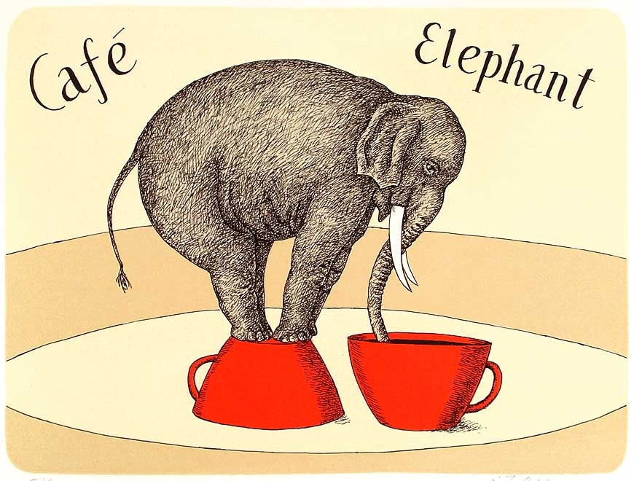

- Opening night on Tuesday 1st March at 6:30pm at the French Institute
Exhibition running until March 26, 2016
- Free entry
On the occasion of the 60th anniversary of diplomatic relations between the Czech Republic and Cambodia, the Embassy of the Czech Republic, in cooperation with the French Institute, present the works of Jiří Slíva, an outstanding Czech cartoonist.

Jiří Slíva is a humorist who prefers drawings to words, and uses a distinctive and unique style based on simple but expressive lines. His drawings are very detailed and accurate, each telling a complete story with a few lines. Through his work, Slíva explores the world of cafés and jazz music, and his cartoons often feature famous people from the cultural and scientific world. Slíva’s favorites include Franz Kafka and Sigmund Freud.
Biography
Jiří Slíva was born in 1947 in the Czech Republic and lives in Prague since 1966. After finishing his studies at the University of Economics, he worked for 8 years as a sociologist. Slíva’s first published drawings appeared in 1972. Since 1979, he has devoted his career full time to cartooning, graphic art, illustration, and painting. He has produced 13 books of cartoons, which have been published in the Czech Republic, Germany, Switzerland, Russia, and France. His drawings have appeared in over 150 books, in numerous Czech newspapers as well as in international journals.

CONTACT PRESS

FRENCH INSTITUTE OF CAMBODIA
Celine Ngi, 012 333 501
celine.ngi@institutfrancais-cambodge.com

EMBASSY OF THE CZECH REPUBLIC
Jana Gašparíková, 0965 863 652
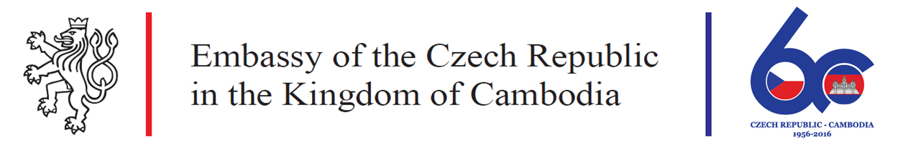
jana_gasparikova@mzv.cz

