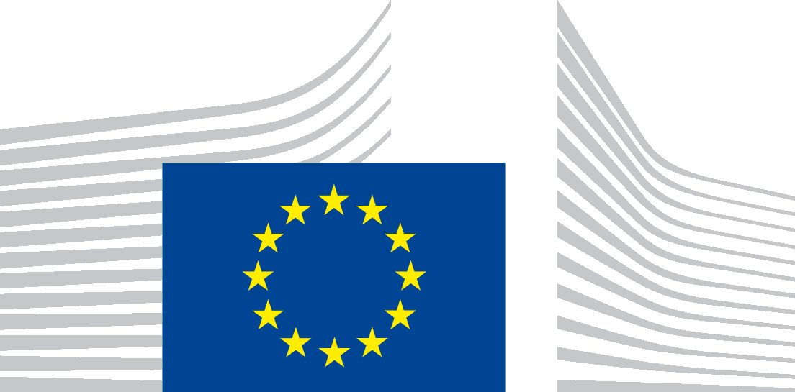 | EUROPEAN COMMISSION  Directorate-General for International Cooperation and Development  Development Coordination East and Southern Africa

Programme for EU Training 6-7 April 2017: The EU Trust Fund for Africa and understanding EU funding opportunities

6 April 2017
09:30-12:30 Presentation on the EU Trust Fund for Africa
The European Union Emergency Trust Fund for stability and addressing root causes of irregular migration and displaced persons in Africa was set up in November 2015 at the Valletta Summit to address the crises in the regions of the Sahel and Lake Chad, the Horn of Africa, and North Africa.
This presentation will give an overview of the approach of the EU Trust Fund for Africa, its priority areas of intervention, governance structure and procedures, and progress on implementation to date. It will focus particularly on the Horn of Africa Window's specific actions and priorities.
Speaker: Olivia Berthon, International Aid/Cooperation Officer from DG DEVCO EU Emergency Trust Fund for Africa – Horn of Africa Window
14:00-17:00 EU funding opportunities: grants applications
This session will offer an insight into the tips and tricks of accessing EU funding opportunities, including practical suggestions on how to apply for calls for proposals, and tips on writing concept notes and full grants applications.
Speaker: Stijn de Lameillieure, International Aid / Cooperation Officer from DG DEVCO Education, Health, Research and Culture Unit
7 April 2017
09:30-12:30 EU funding opportunities: finance and contracts workshop
This workshop will provide concrete guidance on financial and contractual matters relating to EU funding opportunities, including contract rules and procedures, questions on eligibility, co-financing, supporting documents and contract preparation.
Speaker: Frederique Thibout, EU Trust Fund Finance and Contracts Officer from DG DEVCO Finance, Contracts and Audit Unit

