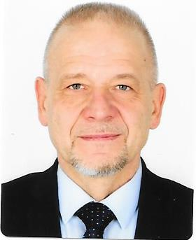
Jiří Baloun
(Lt. General ret.)
Curriculum vitae

Date of birth: March 27, 1961
Place of birth: Prague, Czech Republic
Marital status: Married
Languages: English

Education:
06/2007 – 06/2008 National Defence University, Washington D.C. (MSc – National Security Strategy)
09/1992 – 12/1999 Military Academy, Brno (Ph.D. – Theory of Management, Combat Use of the Forces; external studies)
08/1989 – 06/1992 Military Academy, Brno (postgraduate study)
08/1979 – 06/1983 Military Technical University, Liptovsky Mikulas (Dipl.Eng. – Communication Technology)

Professional career:
01/2020 Ambassador, Embassy of the Czech Republic, Kabul
10/2019 – 12/2019 Ministry of Foreign Affairs
01/2019 – 09/2019 Office of the Minister of Defence
05/2105 – 12/2018 1st Deputy CHOD, the Armed Forces of the Czech Republic
08/2014 – 04/2015 Deputy CHOD – Director of the Joint Operational Center, the Armed Forces of the Czech Republic
08/2011 – 07/2014 Military Representative of the Czech Republic to NATO and EU, Brussels
07/2008 – 07/2011 Director, Force Planning Division, Ministry of Defence
05/2003 – 06/2007 Director, Command and Control, Communication and Information Systems Division, Ministry of Defence
Commander, Signal Corps, the Armed Forces of the Czech Republic
08/2001 – 04/2003 Chief, Communication and Information Agency, the General Staff, the Armed Forces of the Czech Republic
05/1998 – 07/2001 National Representative for Command, Control and Consultation, Permanent Delegation of the Czech Republic, Brussels
12/1993 – 04/1998 Staff positions, the General Staff, the Armed Forces of the Czech Republic
07/1983 – 11/1993 Command positions (starting with platoon commander)

Decorations and Awards (selection):
- Cross of Merit of the Minister of Defence of the Czech Republic, Grade I, II, III
- Medal In Service for Nation
- Medal of the Armed Forces of the Czech Republic, Grade I, II, III
- Medal of the Minister of Defence of the Czech Republic for Service Abroad
- Honourable Insignia of the Premysl Otakar II, the King of Iron and Gold
- Cross of Merit of the Chief of General Staff of the Slovak Armed Forces
- Anniversary Price of the Celakovice municipality, Czech Republic
- Honorary Citizenship of Nebraska, USA

Hobbies:
Sport, culture, motorbikes, gliding

