ED VOKURKA'S "VIRTUOSO VIOLIN" JAZZ ENSEMBLE
Sunday Serenades Series - Annual Afternoon Concert:
Scarborough Civic Centre (S.C.C.), southern end of the Scarborough Shopping Mall
(150 Borough Dr. = at McCowan & Ellesmere)

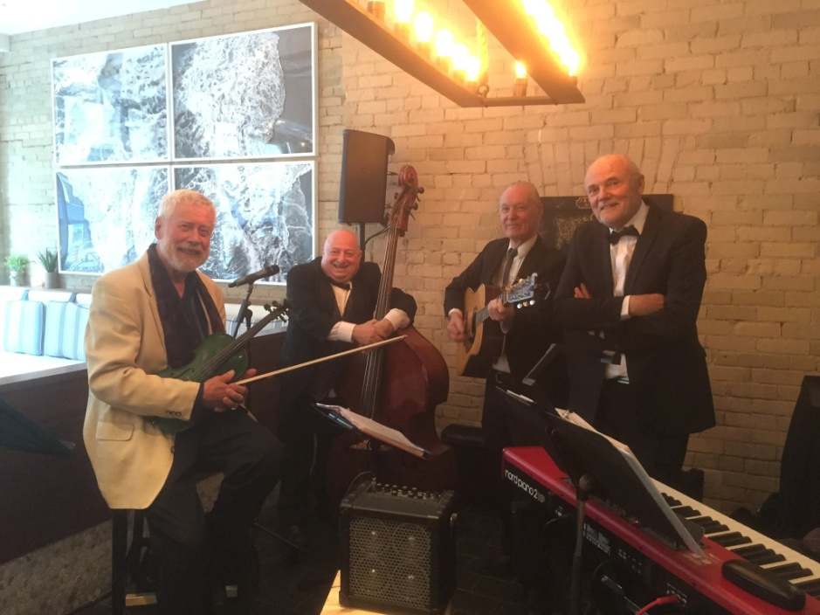

Admission is FREE: = 2 - 4 p.m. "Sunday, Oct-28/2018", main auditorium-vestibule.

Eclectic program includes: Chansons, Broadway highlights, Gypsy Swing & Swing music from 40's, selected contemporary popular music ........, it actually is the unique, elaborate "VIOLIN SHOW" at it's best!
CSR-Centennial Commemoration: Ed was born in Prague, former Czechoslovakia (CSR), living in Toronto since 1967. To honour the 100th anniversary of establishing the free democratic Czechoslovakia on October-28/1918,
Ed Vokurka will include in his regular broad spectrum eclectic program also few short internationally known
"selections from Czech classical composers".

Ed Vokurka's Quartet is: Edward (Ed) Vokurka-Violin, Abbey Sholzberg-Acoustic Bass & Narrator,
John Fletcher-El. Guitar, Josef (Joe) Musil-Grand Piano & El. Keyboard/Synthesizer
(Ed's concerts are traditionally well attended. It is advisable to come earlier to secure the best seats in the auditorium called Rotunda)

"VOKURKA'S VICARIOUS VIRTUOSO VIOLIN"
Canada's answer to Victor Borg
(= Quote from "CANADA'S GOT TALENT" Opera Singer Judge)

Jazz Violinist "EDWARD (ED) VOKURKA" B.Mus.,M.Sc. P.Eng.
< www.edvokurka.com >

Holder of the Czech Republic prestigious State Title "KNIGHT OF CZECH CULTURE"
Winner of the National All-Canadian Musical Competition "CANADA SENIOR STAR FINAL"
Winner of the Ontario Provincial Musical Competition "ONTARIO SENIOR STAR"
Winner of the "CANADA NATIONAL JAZZ AWARD"
Semi-finalist in the "CANADA'S GOT TALENT"

http://youtu.be/RHD6EZiqbzM = Winning Video Example: "MUSICAL COMPETITION CANADA FINAL" - Niagara Falls, ON
https://youtu.be/NP2dGhr0fKU = Ed's Quartet performing: "CON TE PARTIRO" at the Scarborough Civic Centre, Toronto
https://www.youtube.com/watch?v=H-u_vbEPwqs = Paul Anka Song: "MY WAY" - Church audio performance, Toronto

