Annex 8
Case study of selected projects realized within the
Evaluation of Programme of Foreign Development Cooperation of the Czech Republic – the Support of Trilateral Projects of the Czech Entities in the Period 2016-2018
in Georgia

By Joseph Salukvadze
Ivane Javakhishvili Tbilisi State University

Tbilisi, April 2019

Acknowledgment

I would like to express my gratitude to Mr. Jan Černík who kindly advised me regarding the projects which have been conducted by financial support of the Czech government in Georgia. I would like to thank all the respondents for their participation and contribution to this report.

Special thanks go to Tbilisi State University PhD students Temur Gugushvili (sociologist) and Gvantsa Salukvadze (human geographer) for assisting me in launching, transcribing and analyzing interviews.

Table of Contents
Introduction 4
1. Context 4
2. Key Findings 6
3. Summary of projects 8
3.1 Enhancement of the existing models of rural development in Georgia (01.11.2017 – 31.10.2019) 8
3.2 Regional Civil Society Organizations as Vectors of Rural Economic Development (03/04/2017 – 02/10/2017) 9
4. Relevance 9
4.1. Enhancement of the existing models of rural development in Georgia 9
4.2. Regional Civil Society Organisations as Vectors of Rural Economic Development 11
5. Identified outcomes of supported projects 14
5.1. Enhancement of the existing models of rural development in Georgia 14
5.2 Regional Civil Society Organisations as Vectors of Rural Economic Development 15
6. Partnership as one of the key benefits 17
6.1. Enhancement of the existing models of rural development in Georgia 17
6.2. Regional Civil Society Organisations as Vectors of Rural Economic Development 18
7. Sustainability 21
7.1. Enhancement of the existing models of rural development in Georgia 21
7.2. Regional Civil Society Organisations as Vectors of Rural Economic Development 22
8. Visibility 24
9. Recommendations 25
10. Bibliography 26
11. List of interviews, abbreviations 28
11.1. List of interviews 28
11.2. Abbreviations 29
12. Annex 30
12.1. Photos 30
12.2. Further relevant information 32
List of figures
Figure 1. Enhancement of the existing models of rural development in Georgia (Logic model) 3
Figure 2. Regional Civil Society Organisations as Vectors of Rural Economic Development (Logic model) 3
Map 1. Geographical Distribution of Businesses and Non-profitable Local Initiatives supported by PIN in Kazbegi 3
Table 2. Geographical Distribution of Businesses and Non-profitable Local Initiatives supported by PIN in Kazbegi 3
Photo 1. Field trip - Office of PIN and LAG in Kazbegi 3
Photo 2. Field trip – DCFTA resource-desks in Kazbegi 3
Photo 3. Field trip – Local small business Beauty Salon supported (Grant) by PIN in Kazbegi 3

Introduction
This study is based on the research undertaken within the framework of the Evaluation of Programme of Foreign Development Cooperation of the Czech Republic – the Support of Trilateral Projects of the Czech Entities in the Period 2016-2018. It focuses on two out of seven projects supported by this Programme in Georgia in the observed period, i.e. Enhancement of the Existing Models of Rural Development in Georgia (CARE Czech Republic, main donor – European Commission) and Regional Civil Society Organisations as Vectors of Rural Economic Development (People in Need / PIN, main donor – European Commission), both supported in 2018. Regarding to the extent of this document, it is not encompassed in the main report but it is presented as its annex. All findings, however, serve for showing the context and specific examples for the main study. Therefore, the structure of the case study reflects the structure and the main topics of the main report.
The methodology is based on desk research and semi-structured interviews. Due to time constraints of the evaluation process and due to the explicit focus of the evaluation on programme rather than project level, only one project was visited on the spot.
Altogether 11 relevant stakeholders were interviewed, i.e. representatives of supported Czech NGOs, representatives of relevant local, regional policymakers – municipalities, regions, agencies/associations of NGOs or relevant sectors, final beneficiaries of supported projects, the Embassy of the Czech Republic in Tbilisi, representatives of supported local NGOs and Ministry of Environment Protection and Agriculture of Georgia. Field work was undertaken between 24th March and 11th April 2019.

Context
Over the recent decade the problem of agricultural and rural development became one of the priorities of socioeconomic agenda in Georgia. In particular, Rural Development Strategy of Georgia (2017-2020), Agricultural Development Strategy of Georgia (2015-2020), Regional Development Programme of Georgia (2018-2021) and other policy documents have been adopted by Georgian government which confirms the significance of rural and agricultural issues for the national development. Along with tourism and infrastructural improvement, agricultural field is observed as one of the driving sectors of Georgian economy. Enhancement of agricultural production and facilitation of rural development is considered as a necessary measure for rising population living standards.
In order to improve socioeconomic conditions of population, the Regional Development Programme of Georgia (2018-2021) emphasises the importance of the following aspects:
- Stronger involvement of citizens in improving living conditions at the level of municipalities;
- Improvement of local, small scale infrastructure;
- Diversification of local economies and improvement of the infrastructure in rural settlements;
- Support to economic development and improvement of the access to and availability of public services (education, health care, basic infrastructure etc.) in high mountainous areas.
Likewise, Rural Development Strategy of Georgia (2017-2020) highlights the priorities for rural, remote and marginalized areas’ furtherance, such as (i) rising economy and competitiveness; (ii) improving social conditions and living standards. “Diversification of the rural economy through strengthening the agricultural related value chain and promoting various sustainable non-agricultural activities”, states the above-mentioned document. Herewith, the policy paper outlines the significance of local population engagement which is best attested by this statement: “Increase the involvement of rural population (especially youth and women) in the identification of local needs and the determination of solutions to these needs”.
According to the Agricultural Development Strategy of Georgia (2015-2020), the foremost issues are to meet the demand of domestic market and export, increase the level of value added in agriculture, increase the volume of agri-business production and increase the productivity of primary production. Along with the general goals, the policy strategy is associated with the requirements of Deep and Comprehensive Free Trade Agreement that promotes strengthening of farmers businesses to international standards and norms and improvement of quality of their production.
In addition to this, trends of general policy orientation toward rural development, particularly the orientation from agriculture to rural development is obvious. The both projects have greatly contributed to the implementation of rural development. More precisely the activities carried out under these two projects promote non-agricultural economic practices, developing services to enhance quality life of local residents, strengthening participation of local population in decision-making process.
Besides policy documents and strategies, several scientific studies also have been outlining the importance of the above-alluded rural and agricultural development priorities. The latest articles elaborated on the bases of international scientific research results (Gugushvili, Salukvadze, & Salukvadze, 2017; Hüller, Heiny, & Leonhäuser, 2017; Theissen et al., 2019) in Kazbegi municipality stress the inevitable importance of the embracement of linkages between tourism and agriculture sectors. The actual facts show that Deep and Comprehensive Free Trade Area (DCFTA) did not fully use the already acquired scientific findings and knowledge in designing and planning of the projects. The latter could be a scenario where local farmers, on the first stage, would get adapted to the existing standards in the agricultural fields, so as to pave their way for their integration in the local tourism supply chain. All together would help the farmers to produce products in compliance with the international regulations and sell them on EU markets. Owing to the fact, that the local farmers have a low motivation and interest to increase their producing standards, as well as they are sure that it is impossible for them at present to export the production, more relevant for them would be widening their horizons towards the possibilities on how to digest local markets. Local Action Groups (LAGs) have organized and implemented several agri-bazaar events on municipality level, which played significant role in establishment of ties between local farmers and representatives of tourism sector. Successful facilitation of LAG unfolded a lot of fruitful collaboration between mentioned local actors. However, it happened in sporadic, non-sustainable way.
Based on the results of the survey conducted within the framework of the “Fostering Regional and Local Development in Georgia” project, implemented by the United Nations Development Programme (UNDP) with support from the Swiss Cooperation Office in the South Caucasus (SCO) and the Austrian Development Cooperation (ADC), the civic engagement level in local decision-making process with local self-governance is fairly low. Furthermore, the study has indicated that only small portion of population is aware of the appropriate forms of citizens’ participation. In this regard, the crucial role of LAGs should be highlighted, which tries to tackle mentioned challenge through active involvement of local community members in the process of elaboration of policy documents. The establishment of LAGs significantly encouraged the integration of indigenous people in decision-making process and gave their voices the opportunity to be heard and considered.
Hence, the above-mentioned circumstances confirm the high relevance of the supported projects for Georgian reality and existing challenges and are in line with the strategy of the Czech Ministry of Foreign Affairs - Georgia Bilateral Development Cooperation Programme of the Czech Republic 2018-2023 where sustainable development of mountainous regions is qualified as one of three identified objectives of the bilateral cooperation in Georgia. In the meantime, it should be stressed out that when designing and implementing such projects not always already available studies and sources are reviewed and considered. This could diminish the efficiency of the project to certain degree, causing duplication of efforts and ignorance of valuable findings.
For instance, during that period of time when supported projects were launched, international interdisciplinary scientific research with participation of several Georgian universities (e.g. Tbilisi State University, Ilia University, Agricultural University) and academic institutes was being implemented in Kazbegi municipality. The evidence clearly shows that the findings and results of the project AMIES I and AMIES II were not considered and were not used as one of the sources for project development (Akhalkatsi et al., 2017; Hanauer, Pohlenz, Kalandadze, Urushadze, & Felix-Henningsen, 2017; Hüller et al., 2017; Magiera, Feilhauer, Otte, Waldhardt, & Simmering, 2013; Magiera, Feilhauer, Waldhardt, Wiesmair, & Otte, 2017; Paresishvili, Kvaratskhelia, & Mirzaeva, 2017; Shavgulidze, Bedoshvili, & Aurbacher, 2017). The exclusion of such shortcomings from the donor-supported project practices would add value and reliability/solidity to the implemented projects. However, such minor deficiencies do not dramatically reduce the overall undoubtful importance and relevance of implemented supported projects.

Key Findings
Each and every respondent of both projects claim, that the representatives from the Czech Republic are well aware of the existing challenges in rural development of Georgia, hence, their projects successfully meet the actual needs, particularly in the development of economic in limited environments such as mountainous regions.
Enhancement of the existing models of rural development in Georgia
Based on the in-depth interviews it can be concluded that the project from the perspective of various stakeholders successfully responds to the existing challenges of rural development in Georgian reality. As for the primary relevance and the main strength of the project is named its innovative “LEADER" approach which profoundly contributes to the development of rural settlements in the Kazbegi municipality.
Furthermore, the respondents outlined the vital importance of the involvement of the local community in the process of assessment of municipality priorities for the adoption of the relevant decisions. Ultimately, according to the narratives, the implementation of the project resulted in the development of different types of new services in the area, which contributes to the improvement of socio-economic conditions of the local community and ensures the promotion of the municipality’s competitive advantage (e.g. the elimination of medical services deficiency) in terms of tourism growth.
The evaluation of the project identified the formation of the LAG and its role in society building as one of the most important outcomes of the project. Accordingly, the precedent of creating LAGs had profound importance on the national level, which will be a very useful platform with the largest hub of information. LAG is bridging the gap between civil society and local municipality.
Sustainability of LAGs will be guaranteed by the following activities:
- competence of the members of LAGs which significantly increased during the project.
- actual status and recognition of LAG by the government, as a unique institution with the compliant characteristics
- physical working environment, the existence of the office where the members can meet and lead discussions.
- creation of a social enterprise and try to actively involved in this process local as well as international partners in order to obtain financial resources
- LAG members will actively utilize gained knowledge and skills within the project to obtain new grants and collaborate with various donors.
The establishment of Georgian Association of Local Action Groups (GALAG) will provide an opportunity to successfully respond to challenges at the national level. Based on the narratives, in the frame of partnership GALAG tries to connect LAGs with Georgian and foreign NGOs around rural and agricultural thematic topics. GALAG members are actively engaged in gaining the experiences of other countries to share afterwards with LAGs. Ultimately, the development of GALAG will ensure and strengthen the sustainability of the LAGs.
Regional Civil Society Organizations as Vectors of Rural Economic Development
During the evaluation process, the analysis of the respondents' narratives revealed that the project “Regional Civil Society Organizations as Vectors of Rural Economic Development” qualifies as a success of the Czech government as the Czech side successfully identified the crucial topic for rural development and provided financial support, but on the other hand, turned out to be less relevant for the farmers in general. In the case of the Kazbegi Municipality, the following reasons matter mostly: (1) the weak development of agriculture, (2) small land plots, (3) high purchasing demand on the agri-products locally, which is driven by the gradual growth of tourism industry on the one side and on the other, the chronical lack of local production. Due to these reasons, the motivation of farmers to meet the standards envisaged by the DCFTA, which should increase the number of their customers, including the European markets, is fairly low.
The respondents stressed the importance of the DCFTA implementation on the national level, as in its frame is planned the rapprochement of Georgia to the European Union and the introduction of the existing regulations for farmers to enter the EU market. Furthermore, it was outlined that the project is tailored for the farmers, which is reflected in the fact that they try to select the topics for consultation in close collaboration with farmers, in order to meet their needs and interests, to provide relevant literature, and to invite for public meetings the experts in relevant fields.
As the primary weakness and less effective approach of project was assessed to call the local residents for the public meetings or wait for them at the office to consult. Besides, the target group (small-scale farmers, households) for the project focus was not properly selected, because they do not express high interest and aspiration towards the project goals. Particularly, merely provision of the information to the farmers is not enough to encourage households to embrace opportunities or to adopt the new regulation provided/guided by DCFTA. Moreover, it was outlined that the information provided in the framework of the project is very general.
Based on the interview narratives, several recommendations were demonstrated for the furtherance of the DCFTA project:
- Setting up a demonstration farm, provide hands-on knowledge to the farmers;
- To provide more in-depth (specific) knowledge, and more tailored to the selected region or agricultural product;
- The respondent states that the resource tables did not work in the context of farmers;
- Within the project and for its further sustainability the CSOs have identified the groups with a specific interest in DCFTA. Such a group is constituted by young people who express their readiness and willingness to learn more about this opportunity.
The results of the evaluation explored that within the project, the focus is primarily on output, the number of farmers who receive consultations and will be informed about DCFTA. However, the respondents in the interviews do not pay sufficient attention to the final results of the project.
Remarkably, as one of the main outcomes of the project has been identified the fact that in two-years’ time 23 organizations have been strengthened so much that they gained awareness in the essence of advocacy, problem identification and correct positioning (e.g. problems).
As the evaluation has disclosed, all the involved stakeholders agree that the knowledge and information spread on DCFTA between CSOs and partner institutions has most sustainable character. Their opinions differ regarding the resilience of created resource-desks, as one-part states that it has a sustainable nature and should continue to function, whereas the others due to the low interest and motivation of locals believe that alternative forms should be considered in order to bring the needed information to farmers. Despite this differentiation, all of them are on the same opinion that the resilience of the DCFTA project lies on the maintenance of the sustainability of the LAGs and CSOs.

Summary of projects

3.1 Enhancement of the existing models of rural development in Georgia (01.11.2017 – 31.10.2019)
Mercy Corps and the co-applicants CARE, People in Need & the European LEADER Association for Rural Development build in this project on the work accomplished under the ENPARD I “Pilot Rural Development Measures” projects which were implemented in the municipalities of Borjomi, Lagodekhi, and Kazbegi. The project continues to promote a bottom-up, community-led approach to local development and further extends support to the existing Local Action Groups (LAG) in these municipalities. The project design was based upon good practices and lessons learned during the implementation of the ENPARD I projects. They focus on the best ways to make the three LAGs more professional and sustainable, building their knowledge and capacity and providing them with the tools to allow them to operate independently after the project’s completion. The project also supports the disbursal of development sub-grants that will further support the realization of the Local Development Strategies (LDS) that have been developed. In this way, the action aims to achieve the specific objective of the project by improving the quality of life of the rural populations within the target municipalities.

3.2 Regional Civil Society Organizations as Vectors of Rural Economic Development (03/04/2017 – 02/10/2017)
“Regional Civil Society Organisations as Vectors of Rural Economic Development” project aims at promoting the implementation of the Deep and Comprehensive Free Trade Area (DCFTA) in the seven rural regions of Georgia: Imereti, Mtskheta-Mtianeti, Kakheti, Samtskhe-Javakheti, Samegrelo-Zemo Svaneti, Adjara and Kvemo-Kartli, with a strong focus on rural communities. The main target group consists of 19 region-based civil society organizations (CSOs) with mandate and experience working with rural micro- & small entrepreneurs as well as 8 Local Action Groups (LAGs) in Kazbegi, Tetritskaro, Keda and Khulo municipalities.
The project will strengthen the capacities of civil society organisations (CSOs) so that they can help regional small, micro and medium enterprises, as well as individual agricultural producers, to seize the opportunities opened by the DCFTA.

Relevance

4.1. Enhancement of the existing models of rural development in Georgia
Based on the conducted interviews, it is clear that the project from the perspective of various stakeholders successfully responds to the existing challenges of rural development in Georgian reality. Respondents who represent the Czech organization, Local Action Group (LAG), local governmental institution and the beneficiary agree that the project ensures the involvement of the local population in the process of identifying the priorities for municipality development.
The project coordinator of People in Need (PIN) outlines that relevance and the main strength of the project is in its "LEADER" approach. The LAG creates a platform within which through the engagement of different sectors the dialogue, discussion and ultimate decision-making can take place in one common area. Since the participatory approach is an innovation for the Kazbegi Municipality, the project significantly promotes the development of the above-mentioned processes. All these together clearly contributes to Georgian rural development.
According to the information of the representative of Kazbegi local government, the implemented or ongoing work done by LAG is fully in line with its actual activities. He denotes that community-based participatory approach and engagement of local residents in the priority assessment on the initial stage positively affected and ensured the success of the project, as they highlighted exactly those tasks which Kazbegi municipality has faced and needed to tackle timely.
The representative of the LAG clearly outlines the vital importance of the involvement of the local community in the process of assessment of municipality priorities for the adoption of the relevant decisions. According to the respondent, such an approach was a stimulus to create new, innovative services in the daily life of Kazbegi. Notably, the services that were unavailable yet in Kazbegi have been created for the first time thanks to the local population initiation.
The beneficiary states that owing to the fact that the financing of the projects is based on the document of the priorities of the municipality, developed through the active integration of local voices; consequently, the project goal fully meets the needs and challenges of the Kazbegi municipality. The respondent points out that the vision towards the determined priorities of the project is in full correspondence with the community’s need, which clearly indicates the crucial significance of the project.
The respondent from ENPARD highlighted the relevance of the project 'Enhancement of the existing models of rural development in Georgia', the establishment of LAGs, the implementation of LEADER approach in rural development and bottom-up initiatives. The representative states that within this project, the members of LAGs have been successfully informed about the existing experience in European countries.
It is noteworthy that all the respondents highlight the relevance of the project in terms of its contribution to the utilization of innovative LEADER approach for the development of rural settlements in the Kazbegi municipality. The latter implies the expansion of the focus from the development of agriculture to the general advancement of rural areas through the diversification of income sources of rural households, improvement of the quality of life in the context of service development, etc.
The representative of PIN notes that all above-alluded significantly contribute to rural development. During the project, the principle that encompasses the diversification of the main income sources for rural households (not to limit the rural areas advancement merely with agriculture development) is hugely supported. Through the narrative, significant attention is needed to be placed on the provision of accessibility to the services, which will improve the quality of life for the rural population.
According to the representative of local government, with the support of the mentioned project, Kazbegi municipality has already improved quality of existing services, on the one hand, and, on the other hand, acquired new services, such as sewing costumes for the choreography ensemble, dentist clinic, which was in the interest of every resident, etc., because before they constituted a challenge for the local government to attract necessary funding. The respondent denoted that at the initial stage the project was more oriented on the borough Stepantsminda, but in recent years its focus moved mostly to the upper valley, and such a shift is of great importance in order to solve the problems and needs of remote communities. The implementation of the project resulted in the development of different types of new services in the area, which contributes to the improvement of socio-economic conditions of the local community and ensures the promotion of the municipality’s competitive advantage (e.g. the elimination of medical services deficiency) in terms of tourism growth.
Based on the narratives of the project beneficiary, it becomes clear that from her perspective the project was designed in a way to provide new, hitherto previously unavailable services in Kazbegi, including a beauty salon, dental clinic, slaughterhouse, vet-pharmacy, entertainment infrastructure, etc. The development of such services for the first time significantly improved the quality of life and economic conditions (agriculture, tourism) of the local community.

4.2. Regional Civil Society Organisations as Vectors of Rural Economic Development
During the evaluation process, the analysis of the respondents' narratives revealed that farmers do not express great interest in the DCFTA. The causes for this do not differ much by regions. Notably, the primary reasons include the fact that the farmers are not willing or do not have enough resources to digest new markets.
Local civil society organizations trying to attract the interest of local farmers through two primary ways: i) to prepare for the adaptation of the expected regulations in Georgia in the near term; ii) to digest new markets, including the EU. Despite the vital importance of both components, at this standpoint, low motivation of local farmers in both direction is visible, which is due to the following factors: 1. By their attitude, it seems that they will begin to think about how to tackle the situation only when the regulations will be set before them; 2. Existing challenges in rural development, which do not put the need of exploring new markets in the farmers' agenda (because of scarce land, seasonality, the paucity of agricultural production, high purchasing demand on the domestic market).
In the frame of the evaluation, three representatives of a non-governmental organization/LAG supported by the DCFTA project were interviewed. Particularly, the representatives of Kazbegi, Khulo, and Tsnori local action groups.
The respondent from Kazbegi local action group notes that the DCFTA project turned out to be less relevant for the Municipality due to the following reasons: (1) the weak development of agriculture, (2) small land plots, (3) high purchasing demand on the agri-products locally, which is driven by the gradual growth of tourism industry on the one side and on the other, the chronical lack of local production. Due to these reasons, the motivation of farmers to meet the standards envisaged by the DCFTA, which should increase the number of their customers, including the European markets, is fairly low. However, a small portion of the farmers expresses their interest in gaining additional information about DCFTA.
Khulo local action group representative stresses the importance of the DCFTA implementation on the national level, as in its frame is planned the rapprochement of Georgia to the European Union and the introduction of the existing regulations for farmers to enter the EU market. According to the respondent, such knowledge gives them the opportunity to modify their business or change their approaches in a way which won’t contradict to the existing legislation in the country. The project is tailored for the farmers, which is reflected in the fact that they try to select the topics for consultation in close collaboration with farmers, in order to meet their needs and interests, to provide relevant literature, and to invite for public meetings the experts in relevant fields.
In addition, for the Khulo local action group, this project was an important springboard, because they had just started operating and the received resources had significantly contributed to the formation of LAG as a platform, which would fulfil its primary function and provide farmers with relevant information. Furthermore, within the project, they purchased the essential equipment for the functioning of the office. All these components created a history of experiences for Khulo LAG, which helps its representatives to gain the trust of other organizations.
It should be emphasized that in the context of DCFTA, the respondent notes that in some stages it has not been able to fully complete the scale that was initially envisaged. According to the respondent, the reason for that may be several factors, including the novelty of DCFTA issue for farmers, problem of small/fragmented land plots in high mountainous Adjara, weak development of farming, low interest in exploring new markets, as it does not represent an essential need for them.
It is noteworthy that Kazbegi local self-government is not deeply aware and does not have in-depth information about the Regional Civil Society Organizations as Vectors of Rural Economic Development project.
The representative of People in Need points out that the entire organization considers the support and funding of the Czech Development Agency as the most important interventions to cope with the real-life needs that the rural community faces today. For the most important achievement by the respondent is highlighted the fact that the targeted priorities, which are in focus, are selected by the population itself. The respondent also qualifies the mentioned project as a success of the Czech government (because it successfully identified the crucial topic for rural development and provided financial support) but notes that DCFTA is a little bit far at present not only for farmers but for all of us. Based on the narrative, this is the reason why they try to introduce DCFTA to farmers not only as a source of expanding the markets and enter the EU market, but to focus on the upcoming regulations and changes which will occur in near future, for instance in the field of phytosanitary norms, changes in standards of dairy production, etc.
The representative of Civic society organization in Kakheti points out that the approach to call the local residents for the public meetings or wait for them at the office to consult is not effective. The reason is that the farmers do not have a desire to acquire new knowledge or experience; moreover they do not see any necessity in it. From their perspective, one is not able to teach them something new, which they do not know.
The respondent also highlights the targeted mismatch of DCFTA focus. Particularly, large-scale farmers who are interested in marketing, have the capacity themselves to get all the necessary information about the DCFTA, while the small-scale farmers who are target group of the project do not express much interest in obtaining the information about the regulations and opportunities to export their products. Furthermore, they do not have a long-term vision, even do not know what may happen after two years and comprise a less resilient group to work with. Regarding the start-ups, the respondent mentions that the number of farmers, who are more motivated to obtain information, is very small.
The representative of the Rural Communities Development Agency stresses the great importance of the dissemination of knowledge (information) on DCFTA, in order to raise awareness among people about additional opportunities. He states that the information is less spread from the level of local self-government to the non-governmental organizations. Hence, it is crucial to raise their awareness as well as shed new light on the expected benefits of DCFTA.
The representative of ENPARD considers the project 'Regional Civil Society Organisations as Vectors of Rural Economic Development' relevant because it is oriented to spread information on DCFTA and other ongoing changes, especially in the mountainous regions, which is also challenging areas for the ministry. Accordingly, the above-alluded project fills the mentioned existing gaps.
The beneficiary points out that the problems and challenges which were identified at the beginning of the project are already solved, and at present apparently, they may be considered as the strength of Kazbegi (e.g. availability of accommodation units, food facilities, etc.). From the perspective of the respondent, at this stage, when a large part of basic needs is successfully fulfilled in the reality of Kazbegi, the equal and sound geographical distribution of the benefits will be essential. Namely, the primary benefits of the further projects should be shifted from the central settlements (district Gergeti, borough Stepantsminda) to the more distanced villages (Asha, Akhaltsikhe, Karkucha, Kanobi).
According to the Khulo LAG representative, the project would have been perfectly fulfilled through the addition of a pragmatic component, such as setting up a demonstration farm and, based on this, to provide hands-on knowledge to the farmers. The farmers mostly express their interest regarding the standards of agricultural food production, food safety issues, energy efficiency, and analysis of value chains rather than gaining knowledge on free trade in EU market to export their products.
The respondent from Kazbegi local action group notes that due to the fact that LAGs do not have a possibility to obtain a special status, they face several obstacles during the implementation of specific activities including the cooperation with foreign partners. So far, People in Need (PIN) was supporting them through official documents and recommendations, but after the project ends they won't be able to afford this. At present, LAG is actively trying to negotiate this issue with the government.
The representative of Civic society organization in Kakheti highlights that the information provided in the framework of the project is very general. It would have been better to provide more in-depth (specific) knowledge, and more tailored to the selected region. Moreover, she points out that the provided knowledge is not enough to ensure the development of farmers’ businesses. The respondent states that the resource tables did not work in the context of farmers. Therefore, they changed the approach with the alternative method, which is better adapted to farmers. Ultimately, house-visits were used to involve the farmers in this process and raise interest in them regarding DCFTA topics. The respondent also notes that relevant organizations that will be responsible for providing consultations to the farmers should be selected according to their experience and profile. It is impossible to provide quality counselling and develop skills in specific agri-issues in such a short stretch of time. Therefore, the respondent expressed certain concern that the provided information by the training organizations won’t be distinguished by proper expertise and qualification.
According to the representative of the Khulo LAG, individual farmers will probably not be able to export their products in EU markers, because of the small lands, erosion, natural disasters and so on. Therefore, it is more relevant to discuss the export of a particular agricultural product (honey, garlic) with the united forces of farmers’ cooperation.
The representative of the Rural Communities Development Agency supposes that the benefits of DCFTA would be more visible and tangible if, on the first stage, the clusters of the farmers will be established. According to the narrative, the local farms should be strong with the appropriate amount of agri-production, in order to discuss with the farmers their opportunities for furtherance and expansion in terms of new markets.
As the main beneficiaries of the project are LAGs and non-governmental organizations, the respondent from ENPARD (European Neighbourhood Programme for Agriculture and Rural Development) would be willing that the employees of one of the sub-structures of the Ministry of Environmental Protection and Agriculture, namely the Environmental Information and Education Centre, would also undergo the training and learning Practices on this topic to provide the population with in-depth information. The representative of ENPARD outlined that the provision of the information would also have been more effective to the target groups, such as sectoral associations, businesses, or even labelling business, in order to mobilize all parties for getting DCFTA.

Identified outcomes of supported projects

5.1. Enhancement of the existing models of rural development in Georgia
Within the framework of the project, several types of monitoring are being implemented at different levels. It can be said, that the monitoring of the activities of final beneficiaries is an important issue.
The representative of the donor organization states that they have several approaches for monitoring within the project:
- They hire an expert (easiest), and get a report from the expert.
- They have results-based monitoring focused on results, for instance: real application of new knowledge, new skills. They observe also impact.
- Technical monitoring – constructing or delivering some technology.
- Sometimes the Czech Development Agency has the capacity to outsource monitoring, they are sending experts.
The representative of PIN and LAG note that within Kazbegi LAG a monitoring group was established that monitors the funded initiatives within the project. The Kazbegi LAG monitoring group mainly collects information on the implementation stages of the funded projects, whether they have income or not, how many consumers do they have, and so on.
The interviewed final beneficiary, who received financing for a small business (e.g. beauty salon), pointed out that the monitoring process primarily checked if the business progress was implemented in accordance with the established deadlines in the proposal. According to the respondent, people involved in the Kazbegi LAG monitoring process came and checked the construction process of the object, evaluated and observed how long the work was going on.
According to the representative of PIN, for the second important component of the project, development of LAGs and monitoring of their activity, the members of the PIN are themselves involved in the overall implementation of the project, conduct the assessment and provide quarterly reports. In this regard, the respondent from LAG points out that besides the monitoring of the project implementation, which is conducted by independent experts of the EU, Pine and Mercy Corps, they hired an independent expert on their own initiative. This was needed so as to properly assess their current standpoint and the path where they planned to go. But this initiative was for getting overall information about the functioning of LAG rather than for a particular project.
Despite the fact, that the vision of the Kazbegi city hall representative matches with PIN member regarding that the project has significantly contributed to the creation of additional new and innovative wide range of services for the first time, their opinions differ on the main outcome of the project. On the word of the Kazbegi self-government authority, the final result of the project will be the improvement of the quality of service sectors. It is also noticeable for him that these services play an important role in tourism development. From the perspective of the representative of PIN, the primary focus of the project was improving the organizational skills of the LAG members and in general, the preparation of locals for acceptance of LEADER approaches, rather than providing grants.
The representative of LAG also emphasizes the importance of the formation of the LAG and its role in society. According to her, the LAG has acquired the authority over these years, which is reflected in the trustfulness of the local population and other organizations towards them and their activities. Accordingly, the respondent outlines that the precedent of creating LAGs had profound importance on the national level, which will be a very useful platform with the largest hub of information.
As reported by the representative of the LAG, at the initial stage the outcomes regarding the functioning of LAG were not clear, as there was no similar precedent in Georgia. Due to this, it was difficult to demonstrate what could have been the result of this process. In this confusion, the exchange visits in the Czech Republic, where they were acquainted with the practical examples of these groups, was worthwhile.
The final beneficiary believes that for Kazbegi municipality the project actually started at the perfectly right time as it facilitated the acquisition of the components that would help tourists not only to visit but also to stay and use additional services in the municipality.

5.2 Regional Civil Society Organisations as Vectors of Rural Economic Development
Based on the narratives, within the project, the focus is primarily on output, the number of farmers who receive consultations and will be informed about DCFTA. However, the respondents in the interviews do not pay sufficient attention to the final results of the project.
In the framework of the project beneficiary organizations have an obligation to collect information about farmers who have benefited from resource tables or activities carried out within the project. In particular, the data have been gathered on the following issues: i) how many consultations have been conducted; ii) what were the main thematic issues of the consultations; iii) the characteristics of the farmers (e.g. age, sex). In addition to the existing monitoring mechanism, the beneficiary organizations send to PIN quarterly reports, which integrates information about who received consultations, how many services have been delivered by the DCFTA information desk, how many public meetings have been held and on which topics.
As noted above, at the beginning of this chapter, all types of respondents focus on providing information about DCFTA as the final result. They do not focus on the outcome of the dissemination of information and its impact. Hence, it is not determined how the final outcome will be monitored.
In Kakheti, the representative of the beneficiary organization notes that the quantitative outcome was obvious for her because the actual focus was on it; particularly, on providing information to a large number of farmers.
According to the representative of the project partner beneficiary organization, the second type of monitoring was utilized for identifying the number of DCFTA information desk visitors and their peculiarities. This helps them to understand how many people have learned about DCFTA.
According to the project coordinator of PIN, they supervise the monitoring process and have a service contractor who is responsible for monitoring and evaluation. All training was attended by their coordinator and manager. Furthermore, they have a monitoring form, an electronic database where the following information is registered: what challenges they face, what they propose to improve, what has changed and so on. This is internal monitoring. In addition to this, CSOs send narrative and financial quarterly reports. Recently, the organization added monitoring specialist, who will control if all required documents are available. Based on the respondent, PIN also monitors the consultations provided by the DCFTA resource tables, the quality of the beneficiaries' satisfaction. Moreover, all of them are registered in the database. Information is collected on which topics the consultations were provided, how many people are registered, whether the information provided by the resource desk was sufficient or not, in what the obtained information will be used by the farmer. Importantly, they control that people who did not benefit from the information desks are not added in the database for the purpose to artificially increase the number of beneficiaries. For this reason, PIN did a sample, which target group members are contacted by the service provider, who checks that they really used the resource desk service.
As stated by the representative of the beneficiary organization, they used a pre-test and post-test methods to evaluate the quality of provided knowledge through the training modules. The main goal of the partner organization was to monitor whether the training was useful to raise awareness about DCFTA.
The Project Coordinator points out that the project aims to provide farmers and local entrepreneurs with information on DCFTA for their work in the village/community level. The project ensures the reinforcement of the local civic organizations so that after the completion of the project they will be capable to act as mediators between the government and the entrepreneurs/farmers. Within the framework of the project, in two-years’ time 23 organizations have been strengthened so much that they gained awareness in the essence of advocacy, problem identification and correct positioning (e.g. problems). In the opinion of the respondent, this is very ambitious and important. She also claimed that PIN is doing the work which is the responsibility of the state, particularly the Ministry of Economy and Sustainable Development of Georgia. PIN claims to be an intermediary between people and decision makers when some regulation starts activating. They provide people with all the necessary information.
The representative of donor organization examines the outcomes of both, Kazbegi and Khulo LAGs functioning and noted that the availability of grants makes locals motivated to cooperate. Local people, such as teachers, farmers and other stakeholders express goodwill, commitment, and alacrity to participate in LAG. They want to make something valuable for their community in the frame of LAG. As a result of the implemented monitoring, they present new skills, new knowledge, applications. The people are knowledgeable, they can have arguments on why there is not the need to have the various number of guesthouses in the village, for instance.
Furthermore, the respondent provides in-depth information regarding the data collection procedures. Accordingly, data are collected through a survey using the research methods, such as focus groups, in-depth interviews, fieldworks (visits on spot). The process is mostly implemented by staff rather than the outsource. Also, they provide desk research, some indicators, and reports from implementing partners.
Regarding the long-term outcomes on the local and national level, the representative of the donor organization states that LAG is bridging the gap between civil society and local municipality. Hence, he sorts this as the most important outcome. Moreover, he mentioned that people can decide and get information on the local level.
According to the respondent narrative, the best is to have short-term outcomes and proper decentralization, this is the best solution. He thinks that the LEADER is good, but Georgian municipalities also should have/play their role in this process. This is linked to the whole of Georgia, not only to some locations. He lists two scenarios for the outcomes, one positive and one negative:
- Positive: the network is established, local NGOs or regional NGOs get skills on how to inform the local population to food safety standards, renewable energy, etc., they cooperate with Tbilisi. They know how to get and give information to local farmers, people.
- Negative: It is good, but a short-term project. They established the network, trained people, and financing has stopped.
The respondent from ENPARD has information about the project 'Regional Civil Society Organizations as the Vectors of Rural Economic Development', according to which the project aims to raise awareness about DCFTA. More specifically, providing information on expected regulations and prospects for new markets.

Partnership as one of the key benefits

6.1. Enhancement of the existing models of rural development in Georgia
Within the implementation of the project, partnership practices have been identified on the local, national and international level, as well as future perspectives of cooperation.
The representative of Kazbegi LAG points out that her organization is successfully based on the idea of LAGs, which in itself implies a solid partnership between different sectors. Accordingly, the respondent highlights the fact that their meetings with public, business and civil sectors are productive because they do not try to modify each other's interests. On the contrary, they try to find the solution together, which will be more realistic and acceptable for the municipality. As claimed by the respondent LAG is always sincere and if they need support in some issue, they always say it loud to other collaborators. Kazbegi LAG actively cooperates with the local non-governmental organizations, for instance, at present they are working with "Lomek" on the reviving project of one of the remote villages, Gaiboteni, in the municipality. They also have close collaboration with other LAGs and international partners, such as Lithuania, Latvia, Moldova. In fact, as the respondent reports, they cover every level in possible partnership sectors. As stated by the representative of Kazbegi LAG, they also discuss their progress with other LAGs in various municipalities. For instance, they had a meeting in Lagodekhi municipality, where they have discussed their ongoing challenges with Lagodekhi LAG members. It was fruitful gathering because they had already passed this phase and gave Kazbegi LAG members helpful advice based on their previous experiences. Similar activity was implemented also in Borjomi. Since the GALAG is established, it becomes even more comprehensive to do this work. She also points out that in the process of elaboration Kazbegi's strategy, the draft document was exchanged with other LAGs, because each of them was working using patterns/experiences of different countries and they looked for the points that would better work in Georgia’s reality. For this purpose, they needed to get acquainted with each other's working documents.
PIN representative notes that in the frame of partnership, they are planning to purposefully inform Russian tourists who are visiting Kazbegi and afterward plan to continue their trip to Adjara region about the tourist places in mountainous Adjara villages. In order to achieve this purpose, Kazbegi LAG will be in close partnership with representatives of Khulo and Keda LAGs and shape their collaboration. In general, a similar approach is planned to be spread in other areas where LAGs function.
Based on the respondent's narratives of Kazbegi LAG and PIN, they successfully share their experiences with other LAGs, which are forming and developing at present, for instance, Tetritskaro LAG. They emphasize that since the beginning of the first three pilot LAG creations in three municipalities, Kazbegi, Lagodekhi, and Borjomi, each of them took advantage of the different variations of the LEADER's approach according to the experiences of several countries. Today, when the pilot period is completed and they have already been functioning under different approaches, it is necessary to share the accumulated experience and determine the best practices in order to identify the best-tailored approach for the reality of Georgia.
Notably, they are actively cooperating with the LAGs outside of the country, including Latvia, Lithuania, and Moldova. The information between LAGs is permanently shared on international as well as national levels. The representative of Kazbegi Local Action Group outlines that the LAGs have already acquired enough experience in order to determine the best-tailored LEADER approach in terms of Georgian reality, which will be taken into account by the newly-established LAGs.
Importantly, the authority of Kazbegi city hall mentions that they have allocated one person, who is responsible to cooperate with the representatives of Kazbegi Local Action Group and attend the official meetings. He notes that future cooperation between them is largely seen in the elaboration process of Kazbegi development strategy, as the municipality needs to ensure maximum involvement of the local population and to develop solutions to meet their needs. According to the respondent, exactly such a pragmatic partnership is the prospect for the continuation of their fruitful future cooperation.
The partnership between Kazbegi LAG and local self-government was also discussed by the representatives of PIN and LAG. The respondent of Kazbegi LAG notes that recently intrinsic positive changes occur in the relationship with Kazbegi city hall. Despite the fact that partnership is significantly enhanced, the inevitable improvement of the collaboration is vital. The representative from Kazbegi LAG mentioned that during the project they had the necessity to get additional knowledge, approaches, and recommendations from the relevant qualified sources. Furthermore, they needed to get information with Georgian and foreign collaborators regarding the functioning of the social enterprise.
Besides the additional expert knowledge, which they need from time to time for improving their project implementation, they are also focused to find additional resources from donor organizations. The respondent recalls several examples, among them the implementation of the open bazaar of agricultural products, financed by the Austrian Development Fund.
The mobilization of additional financial resources is also needed for small businesses financed in the frame of the project. According to the beneficiary, during the implementation process of the business specific inventory and/or equipment was needed, which was not previously allocated in the budget. Ultimately, the beneficiary provided all this by her own expenses.

6.2. Regional Civil Society Organisations as Vectors of Rural Economic Development
The project involved about 25 local partner organizations. They had different forms of communication during the project implementation process depicted below. This led to some future cooperation. The project partner organization representative recalls several cases of their partnership, when they supported beneficiary organizations and presented a jointly developed project proposal to the donor, for instance, US Embassy, UNEP, etc.
According to the representative of PIN at the regional meeting was revealed that the manufacturers of the bay (Laurus nobilis) were facing a lot of challenges, about which local government was not aware. Within the framework of the partnership, the association of bay producers was officially formed.
Notably, one of the foremost challenges of the project was to spread information on DCFTA and stimulate farmers around these topics. The initially planned approach that farmers themselves would be active and visit the information desks did not work. Therefore, local organizations were looking for solutions together with partner organizations.
According to the representative of ENPARD, various meetings are held to discuss all the challenges undertaken under the programs with the participation of the involved parties in ENPARD.
Representatives of the beneficiary organizations point out that they share with PIN their challenges and possible ways to overcome them:
- Target group slightly changed by adding the youth, which has two primary arguments: (1) young people will share their knowledge to parents, and (2) the provided knowledge will be useful in the future if they decide to engage in the field of agriculture.
- For making the project more effective they combined the dissemination of the information with other projects/objectives, for instance, included in the meetings on European values.
- A representative of the beneficiary organization says that information about DCFTA, its components, will be disseminated through social media, for which additional means are intended to be mobilized.
- Based on the narratives, they also had an internal regional meeting with other beneficiary organizations, which included sharing experience (interestingly, one of the organizers of the partner organization did not consider that the discussion on challenges was honest). A similar meeting was also attended by the LAG representatives and while discussing the challenges, the paucity of interest of local farmers and peasants was revealed. In this regard, their LAG had the advantage of providing financial support for farmers in parallel to the project and they were offered to submit the business idea, which would have been based on the knowledge gained in the project. Merely consultation and knowledge were not enough to increase farmers’ interest regarding DCFTA.
According to the respondent from Khulo LAG, general process of the decision-making is very cooperative - all four partner organizations include them in this process. Furthermore, before any public meeting, they are asked about the thematic topic which can be discussed in selected municipalities. Their opinion is also considered when selecting a topic for the expert invitation. Khulo LAG is frequently sharing documents with other partners on value chain analysis of tangerine production.
In order to share qualified expert opinion, the beneficiary organization plans to invite Nino Zabakhidze (Farmers Association of Georgia) for a meeting with women farmers, in order to share her expertise and information about DCFTA.
As the representative of the partner organization mentions, they invited trainers to conduct training for participants on food safety. According to the respondent, they successfully cooperated in environmental issues and renewable energy with the Greens Movement of Georgia / Friends of the Earth – Georgia. Moreover, they were very closely cooperating with local agriculture information- consulting services, who were also engaged in the implemented events within the project.
Based on the narrative of PIN representative, they have a partnership with the Georgian Association of Farmers, who have created DCFTA Information help desks and share their experiences as well as disseminate information on regional meetings. Also, DCFTA's Working Group was created in RSC network and they exchange information. According to the respondent, Konrad Adenauer Foundation has quality publications on DCFTA, which PIN does not, and they provide them 100-200 printed documents when needed. Sharing of policy documents with the Foundation is also an active process. As stated, PIN also has good cooperation with the Ministry of Environmental Protection and Agriculture’s Expansion Centers and they frequently exchange the information.
Information flow within the project was mainly from the top down, but local organizations involved in the project also prepared value chain analysis documents on a variety of agricultural products. According to one of the organizations, they sent their results to PIN, but they do not know if this document was forwarded to other partners too. Personally, they have not received other value chain documents of partners’ organizations.
As the local organizations state, the financial resources that are provided to them in the frame of the project are scarce. They had to find additional resources not to reduce the efficiency of the project. According to the respondent from the beneficiary organization, during the value chain analysis, for the purposes of the study, active mobility on long distances within the municipality was necessary. For this, it was necessary to spend extra money (30-40 EUR, public transport is not available).
The representative of the partner organization highlights the fact that they had to find additional resources to teach local NGOs the methods of community meetings, such as Agenda for Community Meetings, Day Plan, Sample of Community (500 - 600 EUR).
The representative of PIN noted, that they noticed the need to add extra activities to the project that were not considered in the proposal. Due to the fact that she had previous working experience on the creation of social engagement strategies, she noticed the lack of joint activities. Because of this they have engaged municipalities, added regional meetings and started to communicate actively. A regional meeting was launched, which was financed from the remains of the existing budget. It is planned to hold a regional workshop on the 7 value chains that were created within the project. For this, they need to print large volumes of documents, as farmers are willing to have these documents printed. Hence, they plan to create a consolidated version of the documentation with key information and print it. It needs a substantial sum of about EUR 10,000. At this stage, they have savings of approximately EUR 18,000, which they will use for the rest of the events and printing expenses.
In the context of partnership, the new era has begun for LAGs after the establishment of GALAG, which is an umbrella organization and according to its representative, one of its main functions will be to establish a sound partnership between the Georgian LAG members. Particularly, to share the information, the best practices, the main challenges and possible ways how to tackle them.
The governmental representative points out that they are actively involved in meetings within the framework of the 'Regional Civil Society Organizations as Vectors of Rural Economic Development', moreover, they already established communication with the representation of GALAG.
As the respondent from GALAG reports, the organization will provide an opportunity to successfully respond to challenges at the national level. Based on the narrative, currently, the LAGs are communicating with the self-governance in the frame of their ability, which is not enough for LAG's sustainability. They need to unite, identify important issues, and start addressing these issues jointly.
The representative of GALAG states, that at present in the frame of partnership GALAG tries to connect LAGs with Georgian and foreign NGOs around rural and agricultural thematic topics. GALAG members are actively engaged in gaining the experiences of other countries. Basically, they are participating in conferences where information on the implementation methods of LAG, LEADER and other approaches are shared.
- GALAG became the member of Georgian Alliance on Agriculture and Rural Development (GAARD);
- GALAG is trying to become a member of the European LEADER Association for Rural Development; actively cooperates with them;
- GALAG is trying to create the LAG association with Moldova, which will integrate as members of the LAGs from non-EU countries.

Sustainability

7.1. Enhancement of the existing models of rural development in Georgia
According to the representatives of PIN and Kazbegi LAG, one of the guarantees of sustainability is the competence of the members of LAGs which was significantly increased during the project. They acquired the necessary knowledge and skills to independently operate the functioning of LAGs. In general, they consider that LAGs are already firmly established organizations, able to function successfully in case of certain preconditions. Herewith, the guidelines for the effective functioning of LAGs are developed, which is an important resource:
- Procurement Document;
- Financial Management Guide;
- Project Writing.
It is noteworthy that the opinion of the respondents is similar regarding the huge role of the state in terms of viability and continuation of the project outcomes. According to the representative of the PIN, it is crucial to determine the actual status and recognition of LAG by the government, as a unique institution with the compliant characteristics. The representative of the Kazbegi LAG also denotes that it is essential to obtain the official status in order to establish a proper international partnership and acquire additional financial resources. According to the representative of LAG, the prerequisite for sustainability and continuation of functioning includes the physical working environment, the existence of the office where the members can meet and lead discussions. It is also worth mentioning, that the respondent highlights the high price for the purchase or rent of the land in Stepantsminda as a big challenge.
In order to attract proper financial resources, which are of vital importance for the resilience for LAG, both respondents outline the need for several donors, not one. They think of utilization and mobilizing of existing human capital to independently try to obtain financial support. In this context, they have already taken a few steps forward and have the idea of creating a social enterprise. The representative of PIN mentions that they are working on the creation of a social enterprise and try to actively involved in this process local as well as international partners to discuss jointly the relevant solutions and visions.
Together with the social enterprise, one of the alternatives to obtain needed financial resources is that the LAG members should be capable to use the skills which they acquired during these years. Through such an approach, which has already been experienced by the Kazbegi LAG, they could gain new grants. Likewise, the representatives from LAG and PIN, the authority of the local self-government of Kazbegi also sees governments’ important role in the further functioning of Kazbegi LAG. The municipality is ready for the contribution, even is willing to offer financial support in order to preserve the main features of LAG, which it has in the management of the municipality.
The vision of local government is in line with the LAG representatives’ views regarding its sustainable functioning. The latter implies the engagement of LAG in the management of Kazbegi municipality, particularly in the determination of the priorities and proper managing of the existing budget, and furthermore, the promotion of communication between the local community and decision makers.
Maintaining the stability of small businesses financed within the scope of the project is not less important. According to the beneficiary, it is difficult to find professional staff in Kazbegi in many fields, for instance for the beauty salon; therefore, she decided to bring professionals from Tbilisi to train local staff and in the long run, the respondent plans to have all workers local. At the same time, due to the situation, the beneficiary itself took the license of specific activity for the beauty salon and will carry out the service herself. This approach is also cost-effective.

7.2. Regional Civil Society Organisations as Vectors of Rural Economic Development
The beneficiary and local organizations share the opinion that the knowledge provided for them about the DCFTA has sustainable character. However, it depends on the maintenance of the viability of the LAGs. In such a case, they will be able to provide information on DCFTA for local farmers even after completing the project.
The representative of Kazbegi LAG emphasizes, that the sustainability of the DCFTA completely depends on the resilience of LAGs. If the LAG will exist in the future, to her opinion the issues of DCFTA will become more actual and relevant after some time. For this, they already have a person in charge who is interested in these topics.
According to the representative of Khulo LAG, the database, and resources used by the local action group for the public meetings, events or training constitute huge materials. She points out that no matter to which field of study it is related to, all the resources or experience which they already possess would be of much use for any project of the LAG.
Project partner organization representative shares the similar narrative and states that the project participating organizations, including local organizations, have learned the methodology how to develop value chain analysis, which will be essential for them along with other obtained knowledge.
Above-alluded perspectives are agreed by the representative of PIN, who thinks that the information which they have obtained in the course of training sessions will have the most sustainable character. Also, the experience of being involved in the value chain analysis process, within which seven documents on seven products were been created, are useful. According to the respondent, the beneficiaries have established significant networking ties and contacts with the relevant experts, which will help them in the future. Furthermore, they have become members of Georgian Alliance on Agriculture and Rural Development (GAARD), which is essential for their future activities.
Based on the narrative of the Civic Initiative representative which is also agreed by other organizations is that the knowledge obtained through the project will remain so sustainable that they will definitely consider part of the dissemination of information about DCFTA in other projects. Even more, they have seen groups with a specific interest in DCFTA. According to the Civic Initiative, such a group is constituted by young people who express their readiness and willingness to learn more about this opportunity.
The partner organization of the project states that the created resource-desks have a sustainable nature and they should continue to function. This opinion is not shared by local organizations, who emphasize low interest and motivation of locals, and they believe that alternative forms should be considered in order to bring the needed information to farmers. The representatives of the project partner organization draw attention to the need of local organizations support after the completion of the project to enable them to continue providing information to the farmers. The representative of PIN also places great emphasis on the needed support upon the completion of the project. She puts under question the resilience of all 23 organizations and supposes that it will be a little bit difficult for each of them to take the responsibility and act as real vectors as foreseen by this project.
They are planning to develop the sustainability plan with the PIN for these organizations in order to set a pre-plan regarding what they will do after the project is over. One of the reasons for this was insufficient outcomes of various types of thematic training on free trade with Europe. For some organizations, it was not enough because these topics were completely new to them. Accordingly, the respondent pointed out the necessity to continue the support of these small organizations after completing the project. Admittedly, the respondent highlighted the importance of linking these organizations with each other to have access to consolidated information for future sustainability.
The respondent of donor organization examines the sustainability of the implemented projects and notes that the resilience will be best maintained through the continuation of cooperation between local authorities and LAG. He recalls, that what he monitored in Kazbegi, they have a good relationship, they cooperate and do some joint projects with the municipality. LAG can facilitate in training, inclusion into some programmes to local authorities, and it might be mutually productive. Based on his narrative, it is not 100% secured that LAG is sustainable.
He mentions that as an outcome it could be the cooperation between LAG and local administration, as we see in Kazbegi. The respondent also lists the possible factors for the remaining sustainability of the projects:
1. Sound relationship with the municipality;
2. Funding;
3. Some local-opinion makers (sort of leaders) (Rugby trainer, doctor, teacher) – people as authorities in the community to have in LAG;
4. Proper networking, under ENPARD III, they can also support particular members with sustainability.
When determining the status, a representative of the government notes that at present it is impossible to specify under which type of status LAG could continue functioning. The Ministry is aware of why it is important to define the status and the sustainability issue that is closely related to this challenge. The ministry has not yet formed its vision towards this issue but recognizes the importance of the LAG in rural and agricultural development. At this stage, within ENPARD 4 is planned to consider the sustainability component of LAGs, which will be the precondition for their maintenance before 2023. This issue is still in the process of discussion.
The representative of GALAG notes that the mentioned organizations role in the sustainability of LAGs will be vital in the following issues:
- Support in attracting additional funds;
- Introducing problematic issues to the government and lobbying these issues;
- Determination of LAG status at the national level, taking into consideration its role in rural and agricultural development strategies.

Visibility
Actors, partners, beneficiaries, and representatives of Czech organizations, all noted that they share reports within their obligations.
The respondent from Kazbegi PIN points out that the monitoring materials of the project "Enhancement of the existing models of rural development in Georgia" are shared to the Mercy Corps, which integrates it in its quarterly report. Also, from LAG they episodically send to the Czech Development Agency and the European Union information requests. The representative of Kazbegi LAG shares the monitoring document with the representative of PIN and Mercy Corps.
The project coordinator of the project ‘Regional Civil Society Organisations as Vectors of Rural Economic Development’, explains that the Program Manager Nana Kurashvili and Ondrej Nadvornik, the Head of the mission, are the primary recipients of monitoring report documents.
In order to disseminate information on their activities to wider society, they use various tools, such as newsletters, social networks (organization pages or project page), etc. Importantly, the respondents have denoted that the Czech side accurately assesses the challenges, which are faced by rural Georgia and the agricultural sector today. Accordingly, their contribution is reasonable and properly directed.
The beneficiary organization of the project ‘Regional Civil Society Organizations as Vectors of Rural Economic Development’ claims that the representatives from the Czech Republic are well aware of the existing challenges in rural development of Georgia, hence, their projects successfully meet the actual needs.
The respondent from the partner organization states that the support of the Czech government is in line with Georgia's challenges (e.g. the field of economics, mountainous regions), namely:
- Higher/Professional Education, Human Resources;
- Export and creation of export base, enough number of products are not produced;
- Creation of new jobs.
Project participants also discuss the possible procedural modification issues of the programme. The coordinator of the project ‘Regional Civil Society Organizations as Vectors of Rural Economic Development’ highlights that procedurally, the visitors of the DCFTA resource desks are counted individually and not according to the variety of provided consultation. It is frequent that one visitor gets more than one consultation, however, it is not reflected in the consultancy workload. Therefore, the work of the desk consultant may double, triple or tenfold in order to achieve the desired indicator in the required consultation number.
The beneficiary LAG representative notes that in the project of ‘Regional Civil Society Organizations as Vectors of Rural Economic Development’, she did not have information at the beginning, for instance, how many people should be consulted at the end of the project. Maybe it is very detailed but the respondent thinks that they should know it from the outset what scale and volume of the project are expected to be reached, to know how many people have to attend meetings and get consultations.
The respondent claims that it would be better to know from the outset of the project how many people were expected to attend meetings and get consultations, in order to have better visibility of project’s scale and volume.
The representative of ENPARD claims, that in the frame of the ENPARD once in six months a steering committee, stakeholders meeting is held, which chairman is the ministry. Through such meetings, they get reports regarding the implementation process of several projects.

Recommendations
Most of the respondents noted that the Czech side supports the implementation of important and necessary projects. They promote rural development and agriculture improvement. Based on the narratives, the respondents point out that the Czech Development Agency should continue to launch different projects and strengthen its efforts in various directions of rural development.
The authority of Kazbegi City Hall outlines particular directions as the most significant areas for further support from the Czech Republic:
Ecotourism Development - development of agriculture, its integration into the local tourism supply chain and eventually developing ecotourism. This is necessary to prevent the inflow of food products (dairy products, meat) from "the Capital" (i.e. Tbilisi) and sustain the competitiveness of the local market. Moreover, the local products should be purchased by the local market, which is rapidly expanding.
Implementation of energy efficiency practices - the municipality needs to implement energy efficiency, renewable energy practices. Execution of initiatives in this direction is underway, however additional support is needed. The Kazbegi City Hall is looking forward to more projects that will encourage the proper utilization of technology and natural resources.
Support for young people - additional support for youth, particularly for educational purposes. They can be engaged in exchanged programmes across Europe. From the perspective of the Kazbegi City Hall, such short-term/long-term programs will facilitate capacity building in the priority spheres (e.g. tourism, agriculture) of the municipality. The engagement of local young people in the development of municipality will in itself ensure the integration of European best practices in different sectors. In this regard, the City Hall is ready to contribute financially.
The representatives of Kazbegi PIN and LAG point out that the Czech government can contribute to the recognition of the status of LAG and support them in the formation of the partnership framework. According to them, they can work on this issue with the government and act as facilitators in this process.
The partner organization representative of the project 'Regional Civil Society Organisations as Vectors of Rural Economic Development' puts great emphasis on the embracement of several dimensions for the rural and agriculture development, where also sees the role of the Czech side:
Development of agrarian business - it is important to promote agricultural business development at the local level, development of comMercyal agriculture through engagement of the local population. The mentioned direction will fully benefit local farmers from the opportunities created by DCFTA.
Development of renewable energy and energy efficiency approaches - this is significant for rural development in many ways, including environmental protection, health, economic development, etc. The proper implementation of the methods of using solar energy and biomass are the areas in which the Czech side can significantly contribute.
The coordinator of the project 'Regional Civil Society Organizations as Vectors of Rural Economic Development' highlights that there is a lack of work directly with beneficiaries, farmers and entrepreneurs regarding their needs; the respondent states that it would be better to have more focus on such issues in the project.
The beneficiaries of the project 'Regional Civil Society Organisations as Vectors of Rural Economic Development' list the existing limitations that should be considered in the future:
- The quantity of the number of trained and consulted farmers is very important but more crucial is the quality of their involvement. This is exactly the case when the number of people who attend the events or visit the information desk does not determine overall interest and high level of engagement. Therefore, the suggestion to the donor organization is to change some approaches in this regard when assessing projects, because as they mention, it significantly decreases their motivation and makes to feel that they force someone to visit them. From their perspective, this challenge should be considered by donors.
- It would be very helpful to have some demonstration plot or farm where the farmers will be capable to obtain hands-on knowledge and not be limited merely with the theoretical information.
- DCFTA is a little bit far at present not only for farmers but for all of us. Based on the narrative, this is the reason why they try to introduce DCFTA to farmers not only as a source of expanding the markets and entering the EU market, but to focus on the upcoming regulations and changes which will occur in near future, for instance in the field of phytosanitary norms, changes in dairy production, etc.
- The information provided in the framework of the project is very general. It would have been better to provide more in-depth (specific) knowledge, and more tailored to the selected region. Moreover, the provided knowledge is not enough to ensure the development of farmers’ businesses.
- The resource tables did not work in the context of farmers. Therefore, the approach was changed with the alternative method, which is better adapted to farmers. Ultimately, house-visits were used to involve the farmers in this process and raise their interest regarding DCFTA topics.
- The relevant organizations that will be responsible for providing consultations to the farmers should be selected according to their experience and profile. It is impossible to provide quality counselling and develop skills in specific agri-issues in such a short stretch of time. Therefore, there is certain suspicion that the provided information by the training organizations won’t be distinguished by proper expertise and qualification.
- Individual farmers will probably not be able to export their products in EU markers, because of the small lands and high risks, e.g. soil erosion, natural disasters, etc. Therefore, it is more relevant to discuss the export of a particular agricultural product (honey, garlic) with the united forces of farmers’ cooperation.
- The main target group should be the young generation rather than elderly farmers.
The representative of ENPARD expresses her willingness that the Czech government contributes to the strengthening of the research center of agriculture (the entity under the Ministry) and capacity building of co-workers. As the Ministry of Environmental protection and Agriculture is planning to develop the paying agencies, they would be grateful if the State Agricultural Intervention Fund of Czech Republic would assist them in the development process, particularly in the creation of development strategy, basic framework documents, etc.

Bibliography
Scientific Articles
Akhalkatsi, M., Otte, A., Togonidze, N., Bragvadze, T., Asanidze, Z., Arabuli, G., … Mazanishvili, L. (2017). Agrobiodiversity and genetic erosion of crop varieties and plant resources in the Central Great Caucasus. Annals of Agrarian Science, 15(1), 11–16. https://doi.org/10.1016/J.AASCI.2016.12.002
Gugushvili, T., Salukvadze, G., & Salukvadze, J. (2017). Fragmented Development: Tourism-driven Economic Changes in Kazbegi, Georgia. Annals of Agrarian Science, 15(1), 49–54. https://doi.org/10.1016/j.aasci.2017.02.005
Hanauer, T., Pohlenz, C., Kalandadze, B., Urushadze, T., & Felix-Henningsen, P. (2017). Soil distribution and soil properties in the subalpine region of Kazbegi; Greater Caucasus; Georgia: Soil quality rating of agricultural soils. Annals of Agrarian Science, 15(1), 1–10. https://doi.org/10.1016/J.AASCI.2016.12.001
Hüller, S., Heiny, J., & Leonhäuser, I.-U. (2017). Linking agricultural food production and rural tourism in the Kazbegi district – A qualitative study. Annals of Agrarian Science, 15(1), 40–48. https://doi.org/10.1016/J.AASCI.2017.02.004
Magiera, A., Feilhauer, H., Otte, A., Waldhardt, R., & Simmering, D. (2013). Relating canopy reflectance to the vegetation composition of mountainous grasslands in the Greater Caucasus. Agriculture, Ecosystems & Environment, 177, 101–112. https://doi.org/10.1016/J.AGEE.2013.05.017
Magiera, A., Feilhauer, H., Waldhardt, R., Wiesmair, M., & Otte, A. (2017). Modelling biomass of mountainous grasslands by including a species composition map. Ecological Indicators, 78, 8–18. https://doi.org/10.1016/J.ECOLIND.2017.02.039
Paresishvili, O., Kvaratskhelia, L., & Mirzaeva, V. (2017). Rural tourism as a promising trend of small business in Georgia: Topicality, capabilities, peculiarities. Annals of Agrarian Science, 15(3), 344–348. https://doi.org/10.1016/J.AASCI.2017.07.008
Shavgulidze, R., Bedoshvili, D., & Aurbacher, J. (2017). Technical efficiency of potato and dairy farming in mountainous Kazbegi district, Georgia. Annals of Agrarian Science, 15(1), 55–60. https://doi.org/10.1016/J.AASCI.2016.11.002
Theissen, T., Aurbacher, J., Bedoshvili, D., Felix-Henningsen, P., Hanauer, T., Hüller, S., … Waldhardt, R. (2019). Environmental and socio-economic resources at the landscape level – Potentials for sustainable land use in the Georgian Greater Caucasus. Journal of Environmental Management, 232, 310–320. https://doi.org/10.1016/J.JENVMAN.2018.11.024
Policy documents
2018-2021 Regional Development Programme of Georgia
http://www.mrdi.gov.ge/en/news/2018-2021-regional-development-programme-georgia-unofficial-translation?fbclid=IwAR2s3pKUXKf5PJuMDLfdLpQA5vpc_xp1WyH9JCtV-2dvWhcR18ReF6gFIig
2017 – 2020 Rural Development Strategy of Georgia
http://www.fao.org/family-farming/detail/en/c/877602/?fbclid=IwAR0APiT0Ahgo9ICwqqEoKW1ikmtvWcBIfsEqHs1OtGAQDAVSzcYkU3roij0
2015 – 2020 Strategy for Agricultural Development in Georgia 2015-2020
http://enpard.ge/en/wp-content/uploads/2015/05/strategy.-eng.final_.pdf?fbclid=IwAR2lT35rcIupDQTj4YT_t7rVlH0pGiAQzac6hQFHOrLc5OavnGO7O4W1r_Y
2018 – 2023 Bilateral Development Cooperation Programme of the Czech Republic
https://www.mzv.cz/file/2966217/program_Gruzie_2018_EN.pdf
Project documents
Documents provided by the Czech Development Agency and supported NGOs, notably project proposals, annual reports, evaluations.

List of interviews, abbreviations

11.1. List of interviews
N | Position | Organization | Project | Correspondence | Date of Interview
1 | Responsible representative | Ministry of Agriculture of Georgia | ENPARD | On spot - face-to-face interview: Location: Tbilisi | 10.04.19
2 | The diplomat for development cooperation | the Embassy of the Czech Republic in Tbilisi | - | On spot - face-to-face interview:  Location: Tbilisi | 13.03.19
3 | Responsible representative | GALAG | Enhancement of the existing models of rural development | Distant - Skype Interview | 09.04.19
4 | Project Coordinator | People in Need | Regional CSO as Vectors of Rural Economic Development | Distant – Skype Interview | 25.03.19
5 | Responsible representative | Rural Communities Development Agency | Regional CSO as Vectors of Rural Economic Development | Distant - Skype Interview | 25.03.19
6 | the head of the CSO | Civic Initiative, Kakheti | Regional CSO as Vectors of Rural Economic Development | Distant - Skype Interview | 24.03.19
7 | DCFTA information desk consultant | Khulo LAG | Regional CSO as Vectors of Rural Economic Development | Distant - Skype Interview | 25.03.19
8 | Project Coordinator | CARE | Enhancement of the existing models of rural development | On spot – face-to-face interview: Location: Kazbegi | 31.03.19
9 | Mayor | Kazbegi Municipality | Enhancement of the existing models of rural development | On spot -face-to-face interview: Location: Kazbegi | 01.04.19
10 | the head of the CSO | Kazbegi LAG | Enhancement of the existing models of rural development | On spot – face-to-face interview: Location: Kazbegi | 31.03.19
11 | Project beneficiary | Kazbegi LAG | Enhancement of the existing models of rural development | On spot - face-to-face interview: Location: Kazbegi | 30.03.19

11.2. Abbreviations

ADC - Austrian Development Cooperation
CSO - Civil Society Organization
DCFTA - Deep and Comprehensive Free Trade Area
ENPARD - European Neighbourhood Programme for Agriculture and Rural Development
GALAG - Georgian Association of Local Action Groups
GAARD - Georgian Alliance on Agriculture and Rural Development
LAG - Local Action Group
PIN - People in Need
RCDA - Rural Communities Development Agency
UNDP - United Nations Development Programme
SCO - Swiss Cooperation Office in the South Caucasus

Annex

12.1. Photos

Photo 1. Field trip - Office of PIN and LAG in Kazbegi
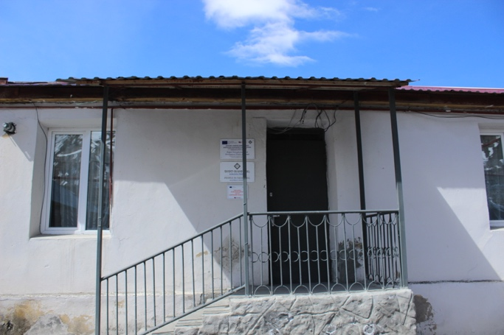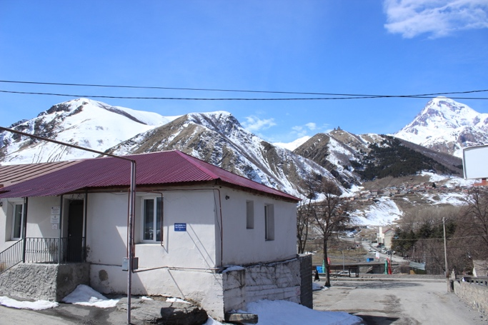

Photo 2. Field trip – DCFTA resource-desks in Kazbegi
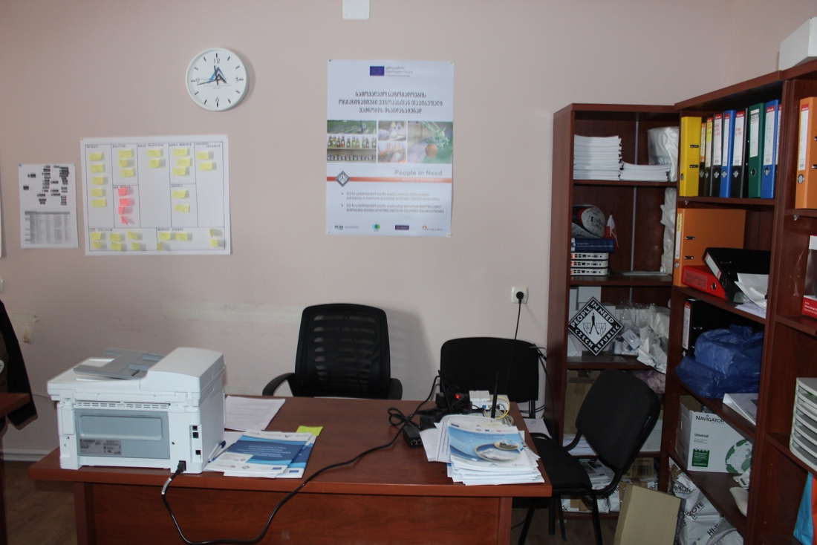

Photo 3. Field trip – Local small business Beauty Salon supported (Grant) by PIN in Kazbegi
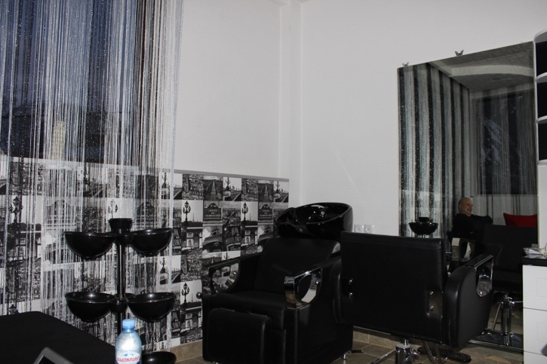

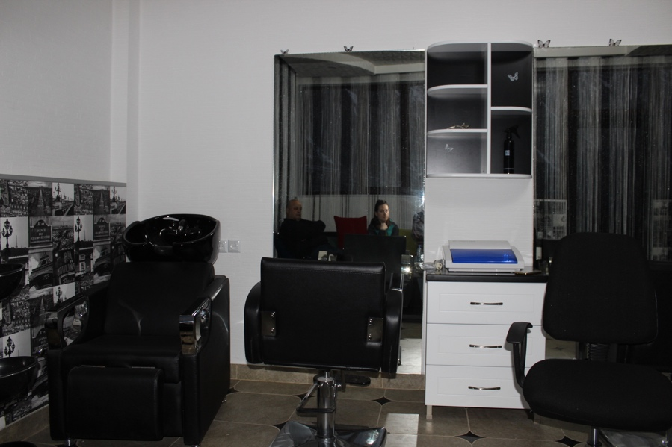

12.2. Further relevant information

Map 1. Geographical Distribution of Businesses and Non-profitable Local Initiatives supported by PIN in Kazbegi
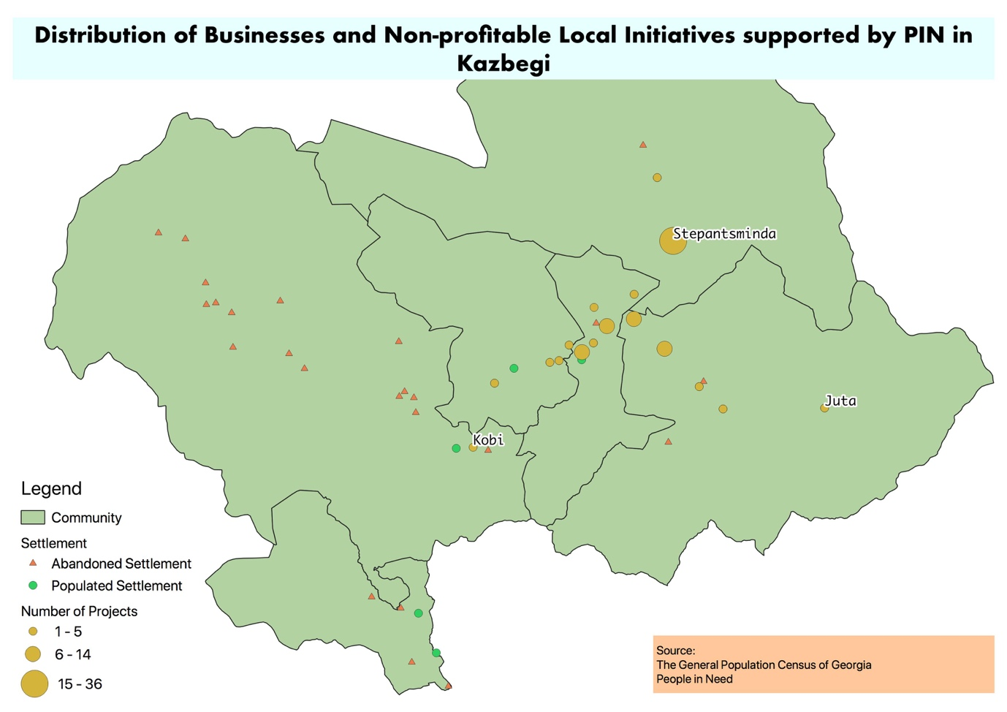

Table 2. Geographical Distribution of Businesses and Non-profitable Local Initiatives supported by PIN in Kazbegi

Settelement | Non-profitable | Agriculture | Tourism | Other | Total
Arsha | 2 | 4 | 1 | 6 | 13
Achkhoti | 2 |  | 2 | 7 | 11
Akhaltsikhe |  | 1 |  |  | 1
Garbani |  | 1 | 2 | 1 | 4
Goristsikhe | 2 |  | 2 | 1 | 5
Toti |  |  | 1 |  | 1
Karkucha | 2 |  |  |  | 2
Kobi |  |  | 1 |  | 1
Sioni | 3 | 3 | 3 | 2 | 11
Sno | 3 | 2 | 2 |  | 7
Stepantsminda | 9 | 2 | 6 | 19 | 36
Tkarsheti |  |  | 2 |  | 2
Ukhati |  | 1 |  |  | 1
Pansheti | 1 |  |  |  | 1
Pkhalshe |  | 1 | 2 |  | 3
Kanobi | 1 |  | 1 |  | 2
Tsdo | 1 |  |  |  | 1
Juta |  |  | 3 |  | 3
Total | 26 | 15 | 28 | 36 | 105

http://www.mrdi.gov.ge/en/news/2018-2021-regional-development-programme-georgia-unofficial-translation?fbclid=IwAR2s3pKUXKf5PJuMDLfdLpQA5vpc_xp1WyH9JCtV-2dvWhcR18ReF6gFIig
http://www.fao.org/familyfarming/detail/en/c/877602/?fbclid=IwAR0APiT0Ahgo9ICwqqEoKW1ikmtvWcBIfsEqHs1OtGAQDAVSzcYkU3roij0 (Objective 2)
http://www.fao.org/familyfarming/detail/en/c/877602/?fbclid=IwAR0APiT0Ahgo9ICwqqEoKW1ikmtvWcBIfsEqHs1OtGAQDAVSzcYkU3roij0 (Objective 3)
http://enpard.ge/en/wp-content/uploads/2015/05/strategy.-eng.final_.pdf?fbclid=IwAR2lT35rcIupDQTj4YT_t7rVlH0pGiAQzac6hQFHOrLc5OavnGO7O4W1r_Y
http://www.ge.undp.org/content/georgia/en/home/library/democratic_governance/citizen-satisfaction-with-public-services-in-georgia--2017.html
2018 – 2023 Georgia Bilateral Development Cooperation Programme of the Czech Republic https://www.mzv.cz/file/2966217/program_Gruzie_2018_EN.pdf
https://www.care.at/projects/geo940/
https://www.euneighbours.eu/en/east/stay-informed/news/georgian-csos-promote-free-trade-eu-rural-areas
http://www.czechaid.cz/en/projekty/regional-civil-society-organisations-as-vectors-of-rural-economic-development/

