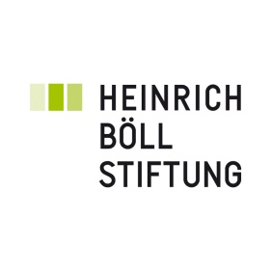
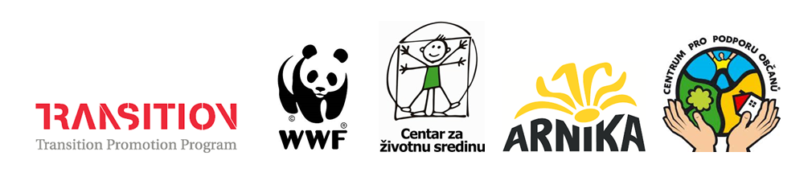

International conference

Legal and practical tools for protecting the rivers of the Western Balkans and their people

Sarajevo - Bosnia and Herzegovina
Hotel Grand Sarajevo

November 27 – November 29

Arnika – Centre for Citizens’ Support (Czech Republic), Center for Environment (Bosnia and Herzegovina) and WWF Adria (Bosnia and Herzegovina) kindly invite you to an international conference organized with the financial support of the Transition Promotion Programme of the Czech Republic and the Heinrich Böll Stiftung foundation.

If you wish to attend please register here.

The Western Balkan countries are unique, with an enormous number of pristine rivers providing habitats for rare and endemic plants and animals. These jewels of nature are threatened by an uncontrolled boom of hydropower plants – over 300 dams are planned on 244 rivers in Bosnia and Herzegovina alone and about 2,700 dams are planned in the whole region. The construction causes irreversible damage to the natural environment and violates the rights of local communities, for example by causing a significant reduction of the drinking water resources. The conference aims to discuss legal and practical tools for the protection of the rivers, brings in international experience and seeks synergies in the protection of the rivers of the Western Balkans and the people dependent on them.

AGENDA

Wednesday 27
Registration (9:00 - 9:30)
Welcome words (9:30 - 10:00)

- Czech ambassador to BiH Jakub Skalnik
- Director of the Heinrich Böll Stiftung Foundation in Sarajevo Marion Kraske

Morning session I (9:30 - 12:30): River protection in Bosnia and Herzegovina and the Western
Balkans – introduction to the problem

Opening of the conference and presentations of the official representatives of the Ministry of the Environment and for Water Management of Bosnia and Herzegovina.

Miloš Orlić from the Coalition for the Protection of Rivers in Bosnia and Herzegovina and a representative of WWF Adria will introduce you to the plans for hydropower plant construction on the rivers of the Western Balkans, its impact and cases of resistance by local people.

Coffee break
Morning session II (12:30 - 14:30): Legislation to protect the rivers – ecologically acceptable flow
Irma Popović Dujmović (WWF Adria): Regional experience in determination of an ecologically acceptable flow
Zuzana Vachunova (Arnika): Ecologically acceptable flow in the European Union – presentation of a study
Ratko Pilipović (an independent lawyer): Proposal of the environmental NGOs for an ecologically acceptable flow in Bosnia and Herzegovina
Panel discussion: Ecologically acceptable flow and obstacles to its implementation in BiH
Representatives of civic society and environmental NGOs, representatives of the Ministry of the Environment and of Water Management of BiH, representatives of the water inspectorate of BiH, representatives of water agencies.
Lunch (14:30 - 15:30)
Afternoon session (15:30 - 18:00): International experience
RNDr. Josef Fuksa, CSc. (T. G. Masaryk Water Research Institute): Monitoring and information tools used to protect the quantity and quality of waters in the Czech Republic
Martin Skalsky (Arnika): Access to information on constructions on rivers in Europe – presentation of a new study and of an online information portal
Joint dinner and welcome drink (18:00 - 21:00)
As a part of the evening programme a showing of the film Blue Heart and Black Shadow of Green Energy will take place on the premises of the hotel.
Thursday 28
Morning session (9:00 - 12:00): Tools for nature protection
Vlastimil Karlik (Arnika): Why we need Natura 2000 – experience in the EU and benefits for nature protection
Representatives of Center for Environment and of the Institute for Natural and Cultural Heritage of the Republika Srpska: Proclamation of the springs of the river Sana as a natural monument – case study
Coffee break

Implementation of a nature protection law and of an ecological network in Bosnia and Herzegovina: current situation and obstacles
Representatives of the Institute for Natural and Cultural Heritage of the Republika Srpska, representatives of Ministry of the Environment of BiH, representatives of civic society and environmental NGOs.

Lunch (12:00 - 13:30)

Afternoon session (13:30 - 19:00): NGO session

Parallel workshops (13:30 - 16:30)

- Current trends in financing the hydro boom in Western Balkans
Pippa Gallop (CEE Bankwatch)

- Natura 2000 as a tool for nature protection: how civic society can enforce the establishment of Natura 2000
Vlastík Karlík (Arnika, Czech Republic)

Coffee break

Closing session (17:00 - 19:00): Discussion “What can we do together?”
Dinner (19:00 - 20:00)

Friday 29
Regional experience (9:00 - 16:00)
The last day of the conference will be dedicated to the sharing of experience between activists and representatives of the local communities from the Western Balkan area and other international actors in the region.
Vlastik Karlik (Arnika): Collaboration of the academic and public sectors with NGOs through examples from the Czech Republic
The Coalition for the Protection of Rivers in Bosnia and Herzegovina
Coalition 27 (Bosnia and Herzegovina): Discussion on the EU accession process with focus on the water sector
and others TBC...
Closing session (16:00 - 18:00): Adoption of the Sarajevo Declaration

