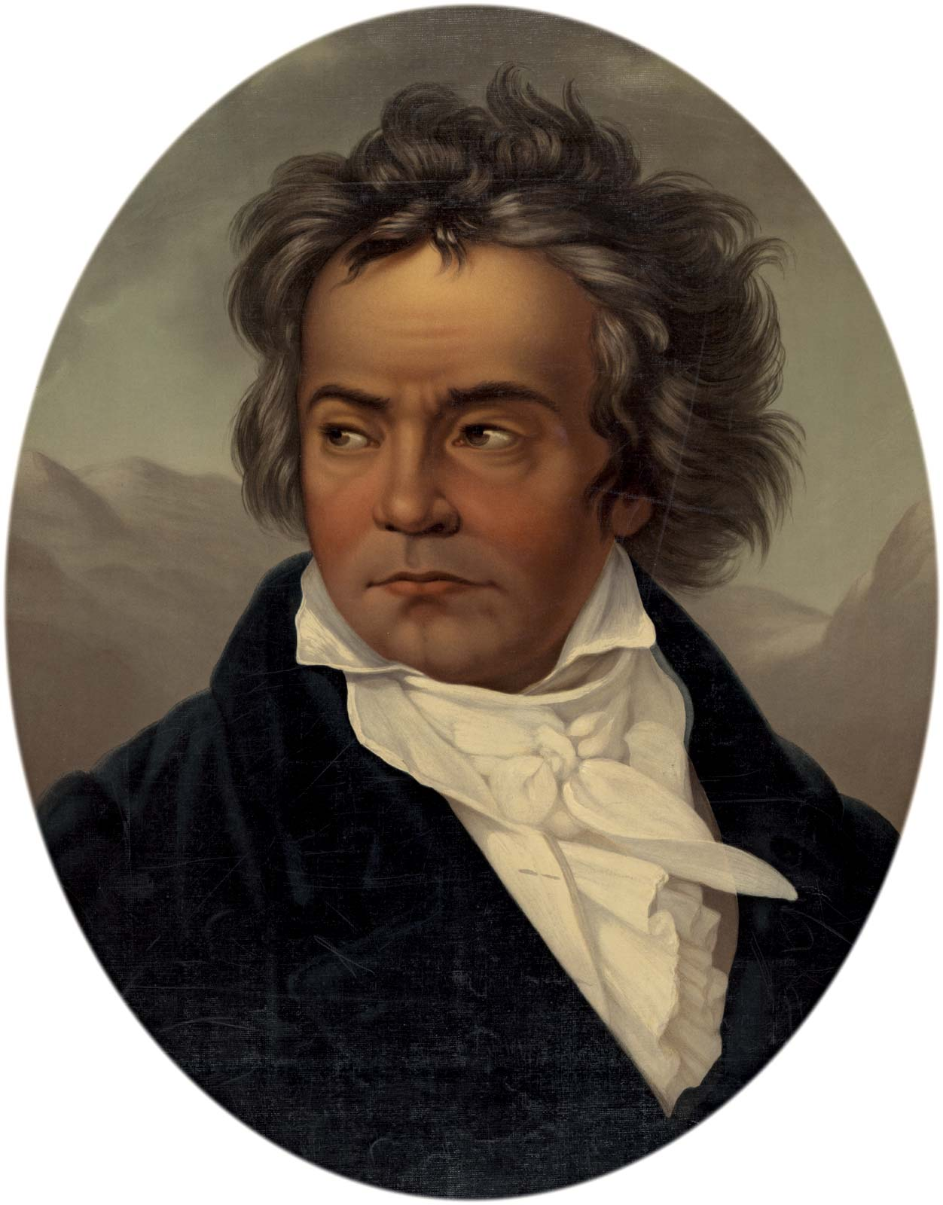
Ivana Snaidr presents chamber concert
BEETHOVEN and FRIENDS
celebrating Beethoven’s 250th birthday

****************

Haydn : Trio in G for piano, violin and cello

Mozart : Sonata in B flat for bassoon and cello

Beethoven : 7 Variations on theme from Mozart’s opera
Magic Flute for cello and piano

Beethoven : Trio opus 11 for clarinet, cello and piano

Clarinet: Kate Stockwin, Piano: Annabelle Clucas
Cello: Ivana Snaidr, Violin: Marcela Taylor, Bassoon: Paul Williams
Reader: Ivan Kolarik OAM
Czech House Sunday 23 February 2020 at 3pm
Queensberry Street, North Melbourne, Tickets $15
Bookings: 0408 088167, 0412525769 or at the door

