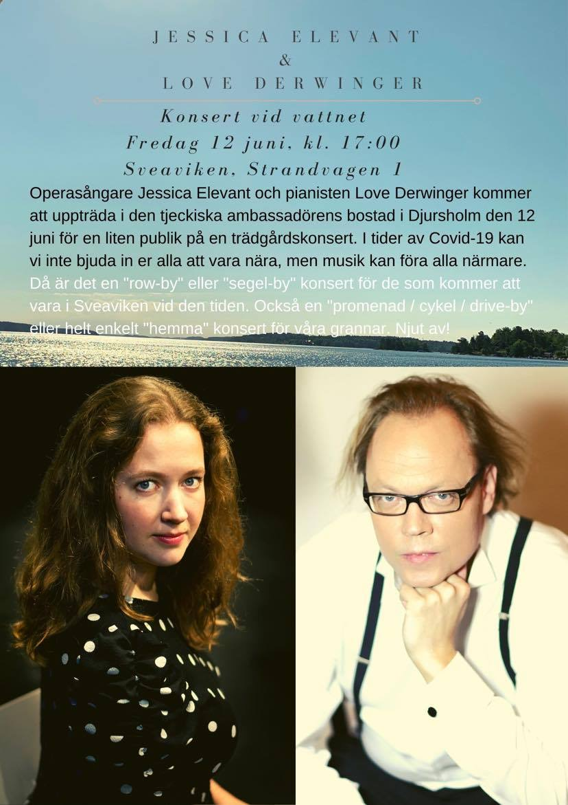

Order of performance

Garden concert June 12th 2020
Jessica Elevant - soprano
Love Derwinger - piano

Dich, teure Halle aria from Richard Wagner’s Tannhäuser
Var det en dröm song by Jean Sibelius, text by Josef Julius Wecksell
Zueignung song by Richard Strauss, text by Hermann von Gilm
Pan song by Ture Rangström, text by Bo Bergman
Casta diva aria from Vincenzo Bellini’s Norma
Svarta rosor song by Jean Sibelius, text by Josephson
Dove sono i bei momenti aria from Wolfgang Amadeus Mozart’s Le nozze di Figaro
Měsíčku na nebi hlubokém aria from Antonín Dvořák’s Rusalka

