# COVID-19: An overview of the epidemiological situation in the Czech Republic

# Summary as of March 15, 2021

|  |  |  |
| --- | --- | --- |
| **Overall Summary** | | |
| **Confirmed cases  (total/ 7 day average)** | **1 402 420 / 10 993 ↑** | **14-day case notification rate per 100 000 inhabitants** |
| **Active cases (unofficial estimate)** | **161 874 ↑** | **Czechia: 1572.72 ↑**  **EU/EEA: 328.94** |
| **Healed** | **1 214 056** | **14-day death notification rate per 1 000 000 inhabitants** |
| **Death** | **23 379** | **Czechia: 238.64 ↑**  **EU/EEA: 66.97** |
| **Anti-epidemic score** | | |
| **71/100 ↓**  **Risk Level: 5 (Critical) →** | | |
| **Vaccination** | | |
| **Total vaccines applied (total/ 7 day average)** | | **1 081 907 / 34 565 ↑** |
| **Total vaccinations completed(total/ 7 day average)** | | **299 077 / 4 930 ↑** |
| **Testing** | | |
| **RT-PCR tests (total/ 7 day average)** | | **5 821 165/30 256 →** |
| **Rapid antigen tests (total/ 7 day average)** | | **3 915 085/104 037 ↑** |
| **7 day average of ratio of the newly positive inhabitants tested for COVID-19 to the number of RT-PCR tests** | | |
| **33,6% →** | | |
| **Hospitalization** | | |
| **Currently hospitalized** | **8 362 ↑** | **Proportion of hospitalized patients in severe condition** |
| **Patients in intensive care unit (ALV, ECMO)** | **1 930 ↑** | **23,1 % ↑** |

# Highlights

* The development of the epidemiological situation **is still unfavourable with high community transmission.**
* After weeks of deterioration, there has been a slight decrease in confirmed cases in the last week**, indicating a gradual decrease in the spread of the epidemic in the population, but the burden on the hospital is still at its limit.**
  + The Czech Republic is **the worst affected country in the EU** in terms of 14-day notification rate of newly reported COVID-19 cases per 100 000 inhabitants and **the second worst in the death notification.**
  + The spread of a more contagious mutation (the so-called British mutation) of the SARS-CoV-2 virus in the Czech territory prevails. The so-called South African mutation was also newly recorded.
* As of 27 February, **new state of emergency applies in the Czech Republic**. It will last until 28 March and further extension is expected.
* **Further restrictive measures have been taken** - ban on movement among districts, the obligation to wear a respirator or mask with a nano filter, and mandatory comprehensive testing of employees and public office staff has been launched (see below).
* The epidemic is unevenly distributed in the Czech Republic, the pandemic gradually spreads throughout the country from west to east.
* **Hospitals are still under immense pressure.** The capacity of hospitals has reached almost its maximum (new maximum of 9 000 patients last week) and there is a high pressure on the capacity of medical staff.
  + The number of patients in serious condition is the highest one since the beginning of the epidemic. **During this week, it reaches the absolute maximum - almost 2 000 patients in serious condition.**
  + Interregional transports of patients from regions where capacities are at a maximum are carried out.
  + Currently, only 12% of beds are available in intensive care units and 24% in standard beds with oxygen.
  + The government has allowed hospitals to deal with staff shortages by calling outpatient specialists and medical students.
* A significant increase of the antigen tests performed (more than 100 000 tests per day) has been observed since the start of mandatory testing of selected employees.
* Significant progress has been made in the number of vaccinations reported per day (the new daily maximum is 50 000).
* According to the Czech anti-epidemic system, **the summarised risk index for the Czech Republic after the rise in recent weeks fell at 71.**
  + This value corresponds to alert level four of the Anti-Epidemic System. However, most indicators signal the need to **remain in the fifth – highest - level of the Anti-Epidemic system.**

|  |
| --- |
| **Current epidemiological measures**  (list of all adopted measures can be found [here](https://www.vlada.cz/en/media-centrum/aktualne/measures-adopted-by-the-czech-government-against-coronavirus-180545/)) |
| * The free movement of persons is prohibited from 9:00 p.m. until 04:59 a.m. (with exceptions). * From 1 March to 21 March, it is forbidden to leave the district (or the City of Prague), in which the person in question has permanent residence or domicile, without good reason, such as travel to work or to a doctor. * Public gatherings are limited to two people (does not apply to household members). A maximum of fifteen people is able to attend weddings, funerals and entry into a registered partnership. * Only defined basic types of retail goods and services are allowed. As of 1 March, the number of exemptions from the ban on the presence of the public in work premises is reduced. * Restaurants and other catering establishments must be closed from 9:00 p.m. until 04:59 a.m. and may only run take-out windows. * Cultural institutions such as galleries and museums are closed. Only professional sports without spectators are allowed. * For church and religious gatherings, the permitted capacity in churches and prayer rooms has been reduced to a maximum of ten percent of the seating capacity. * As of 27 February, new state of emergency applies in the Czech Republic. It will last until 28 March. * As of 1 March, in the built-up area of a municipality, it is mandatory to wear respirator or nano filter mask everywhere outside. * As of 1 March, full-time school/ kindergartens attendance is closed with the exception of a children's group at a medical or social services facility. * Mandatory comprehensive testing of employees and public office staff has been launched. Only employees with negative covid test result (not older than 7 days) will be admitted to workplace. * Companies employing 250 or more workers started testing on 5 March (from 12 March only employees with negative test results may present at the workplace). Companies with 50 to 249 employees started on 8 March (with deadline on 15 March). Companies with 10 - 49 started on 26 March. * Mandatory public office staff testing for employers having 50 and more employees started on 10 March (from 17 March only employees with negative test results will be admitted to workplace). * There is a valid exception for employees that recovered from Covid-19 in the last 90 days, fully vaccinated individuals (final dose administered at least 14 days ago) not exhibiting any symptoms. Mandatory testing is not intended for home office based workers. |

Figures of current epidemiological situation

Source: IHIS

Source: IHIS

Source: IHIS

Source: IHIS

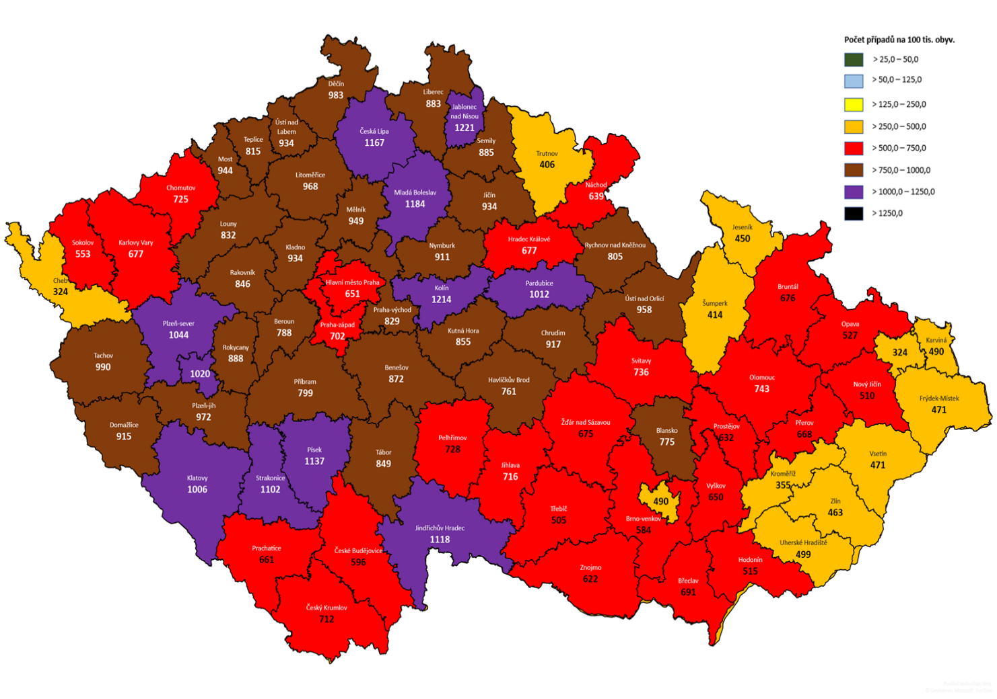

Confirmed cases (by districts per 100 thousand inhabitants)

Source: IHIS