(Unofficial translation)
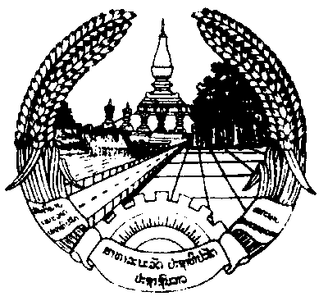

Lao People’s Democratic Republic
Peace Independence Democracy Unity Prosperity

Prime Minister’s Office
No. 627/PMO
Vientiane Capital, May 07, 2022

Notice
To: Ministers, heads of equivalent organizations;
Subject: Guidance on measures for entering-exiting Lao PDR and relaxed measures during the COVID-19 pandemic.

- Pursuant to the Agreement on Organization and Function of the Prime Minister’s Office No. 574/PM, dated September 28, 2021;
- Pursuant to the actual situation for entering-exiting Lao PDR by regional and international visitors;
- Pursuant to social feedback on measures for entering-exiting Lao PDR during the COVID-19 pandemic;
- Pursuant to a study conducted by the National Taskforce Committee for COVID-19 Prevention and Control.
Prime Minister’s Office has the honor to inform you with regards to the agreement reached and guidance provided by the Government for proper acknowledgment and implementation as following:
- Agree to relax the following entry-exit measures:
- Open all international checkpoints allowing Lao citizens, aliens, foreign nationals and stateless to enter and exit Lao PDR.
- Allow citizens of any country with bilateral and multilateral visa exemption agreement with the Lao PDR to enter the country without applying for visa.
- For those coming from countries with no visa exemption agreement with the Lao PDR, visitors can apply for visa via Lao Embassy or Consulate General located in their country or through an e-visa system or apply for visa on arrival directly at the international checkpoint where visa service is available.
- Lao citizens, aliens, foreign nationals and stateless at the age of 12 years or above, who do not have a vaccination card certifying their fully-vaccinated status, must present an ATK test result valid within 48 hours before their departure. Upon arriving Lao PDR, the person will not have to be tested for COVID-19 again at the airport or border checkpoint. Fully vaccinated visitors holding a vaccination card can enter the Lao PDR normally without having to be tested for COVID-19 again, both before departing from their home country and once arriving Lao PDR.
- Foreign nationals entering Lao PDR and getting infected with COVID-19 will have to take responsible for all costs incurred from medical treatment on their own. Patient can receive medical treatment from public hospital, private hospital or do self-care at home (home isolation) by following instructions provided by the Ministry of Health.
- Allow all types of vehicle to enter-exit Lao PDR as it would normally be prior to the COVID-19 pandemic. Assign the Ministry of Public Works and Transport to issue further instructions regarding the using of private, transport and tourism vehicles in entering-exiting Lao PDR, in alignment with bilateral and multilateral agreements partied by Laos.
- Assign line ministries, ministry-equivalent organizations and local authority at all levels all the way to entrepreneurs to be prepared in all aspects in welcoming tourists, particularly in improving tourist sites, hotels, restaurants, transportation services and other facilities closely associated with tourism to ensure they meet required standards and quality. Service and tourism is a shared responsibility borne by all parties in society in order to help recovering the economy and improving people’s living conditions.
- Allow entertainment venues and karaoke places to open with strict implementation of COVID-19 preventive measures.
- Assign the National Taskforce Committee for COVID-19 Prevention and Control in collaboration with the Ministry of Health to continue monitoring and evaluating the COVID-19 pandemic situation, especially when new variant emerges, to guarantee effective and efficient prevention, control, testing and treatment. Moreover, continue the vaccination based on target set by the government.
- The above-mentioned measures from 1-5 shall be implemented starting from May 09, 2022 onward.
Therefore, this notice is made for proper acknowledgement and implementation.
Minister,
Head of the Prime Minister’s Office
Alounxay Sounnalath

