HUDEBNÍ AGENTURA CAMERATA

MUSIC AGENCY CAMERATA

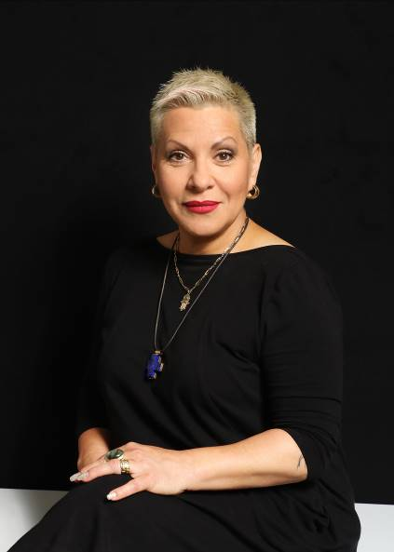
DAGMAR PECKOVA - mezzo - soprano

Dagmar Peckova, winner of the 2000 Thalia Award for her role as Carmen in the opera of the same name, recipient of the highest regional honour of the Award of Merit for the Pardubice Region, the highest award of the upper house of the Czech Parliament - the Silver Medal of the President of the Senate, was born in Chrudim. She studied at the State Conservatoire in Prague and after attending the Sächsische Staatsoper in Dresden was a member of the Staatsoper in Berlin for several years.

During her successful professional career, she has performed on world opera and concert stages such as Bayerische Staatsoper, Carnegie Hall New York, Concertgebouw Amsterdam, Grand Théâtre de Genève, Hamburgische Staatsoper, National Theatre in Prague, Opéra de Monte-Carlo, Opéra National de Paris, Opernhaus Zürich, Royal Opera House Covent Garden London, San Francisco Opera, Sächsische Staatsoper, Staatstheater Stuttgart, Theater Basel,Théâtre du Châtelet Paris, Teatro Sao Carlo v Lisabonu, Wigmore Hall in London etc.

She has appeared repeatedly at prestigious international music festivals such as the Edinburgh International Festival, Salzburger festspiele, Prague Spring, Smetanova Litomyšl or the Schleswig-Holstein Musik Festival, where she was a resident artist in 2004.

She sung under the artistic direction of eminent conductors such as J. Whitehall, S. Bychkov, S. Cambreling, P. M. Davies, Ch. von Dohnanyi, Ch. Dutoit, Ch. Eschenbach, V. Fedoseyev, M. Honeck, N. Järvi, Ch. Mackerras, K. Nagano, F. Luis, V. Neumann, L. Pesek, K. Petrenko, G. Prétre, P. Schneider, S. Young or W. Sawallisch.

She has repeatedly cooperated with prestigious orchestras such as Bamberger Symphoniker, BBC Symphony Orchestra, Cleveland Symphony, Czech Philharmonic Orchestra, Dresden Philharmonic Orchestra, DSO Berlin, London Symphony, Münchner Philharmoniker, NHK Symphony Orchestra Tokyo, Orcherstre de la Suisse Romande, Pittsburg Symphony, Orchesters of WDR, SWR, MDR and NDR, Philharmonisches Staatsorchester Hamburg, PKF - Prague Philharmonia, Royal Liverpool Philharmonic Prague FOK, The Philharmonia, Tonhalle Zürich, Wiener Philharmoniker, Wiener Symphoniker etc.

Her recordings came from record labels Hänssler Classic, Teldec, Warner Music and Supraphon, where she released her next albums (Wanted, Mahler's Song of the Land, Dreams, Nativitas, The Magical Gallery and Exaltatio). She holds three Gold Records of Supraphon - for the album Dvorak's Songs (2001) and for the albums Wanted (2017) and Nativitas (2018).

She is also heavily involved in her own concert projects - such as the opera recital Sinner (2015), the cabaret revue Wanted (2017), and songs with Christmas themes Nativitas (2018) and Exaltatio (2020). In 2017, she founded the Zlatá Pecka Music Festival in her birthplace, where she is the principal artistic guarantor of projects to support young emerging talents - Talentissimo (for extremely talented children under 15) and Pëvissimo (for emerging singers).

Dagmar Peckova's highly significant artistic activities include her current performance activities - a performance by Jan Jirána Carmen y Carmen, in which she co-stars with Bára Hrzánová as Carmen, and Terrence McNally's Masterclass in the role of Marie Callas, which she studied at the Mladá Boleslav Municipal Theatre.

www.dagmarpeckova.com
www.facebook.com/DagmarPeckovaOfficial/
www.youtube.com/playlist?list=PLW0vIuAMsrRSl5DbVV1v5wv0uSjm4G3uA

Kontakt: Camerata s.r.o. - Artists Management
Martina Straková
e-mail: production@camerata.cz
www: www.camerata.cz
Senovážné nám. 23, 110 00 Praha 1
tel.: +420 224 142 131, +420 776 356 689

