COVID-19: An overview of the epidemiological situation in the Czech Republic

29 October 2020

Current epidemiological situation
- As of October 29, the Czech Republic has registered total of 297 013 cases. At the moment 174 965 cases are active.
The first case of infection by SARS-CoV-2 was detected on March 1. Since then the number of newly detected cases was steadily rising, reaching its peak by end of March. In April the Czech Republic witnessed a rapid decrease in cases thanks to the strict measures adopted by the government.

As rest of the EU, the Czech Republic has been facing rise in numbers of newly detected cases since beginning of summer as a reaction to easing of the restrictions. However, since the beginning of September a steep increase of new cases was registered. Also, due to increase of testing, the Czech Republic has registered a record number of daily increase of cases – 15 663 new patients on 27 October.
The rise of new cases began mainly in local clusters which were being handled by measures taken at local levels. However, the infection spread also outside of the local outbreaks and wider measures needed to be adopted. As of now, the Czech Republic is experiencing community spread in all regions.

Alert system
Current epidemiological situation in the Czech Republic varies across the regions. A system that marks the individual districts according to the degree of COVID-19 contagion has been launched in the Czech Republic. The system is divided into four alert levels – white, green, yellow, and red, known as the “traffic light scheme”. The white means zero or negligible risk, the green indicates the incidence of contagion without community transmission, the yellow indicates incipient community transmission, and the red means rising or lasting community transmission in the district. Current situation is being updated regularly and is available online in English - https://koronavirus.mzcr.cz/en/covid-19-risk-score-for-czech-districts/
ALERT LEVEL | EPIDEMIOLOGICAL CRITERION | CHARACTERISTICS | EARLY WARNING LEVEL
0 | ZERO OR NEGLIGIBLE RISK | - Official expert sources (especially the World Health Organisation or European Centre for Disease Prevention and Control) inform about the fact that disease contagion has been reported abroad | 0
I | OCCURRENCE OF INFECTION IN CZ WITHOUT COMMUNITY TRANSMISSION | - Sporadic cases occur  - Local clusters occur  - Local epidemics occur  - Combination occur: sporadic cases / local clusters / local epidemics | 1-3
II | INCIPIENT COMMUNITY TRANSMISSION IN CZ | - Occasional cases with an unclear source of contagion, which start to spread in an as-yet-unaffected community – among persons who did not visit an affected area or were not in contact with a known source | 4-7
III | GROWING OR PERSISTIN COMMUNITY TRANSMISSION IN CZ | - Daily incidence of cases within community transmission has a consistent rising or persisting trend | 8-10

Alert levels are published primarily as information for citizens, as a system of early warning about the changing epidemiological situation. Twenty-five parameters, which are the result of the weekly summary of daily monitoring, are evaluated. The final decision about the alert level for the given area is the outcome of evaluation by epidemiologists and hygienists. Assessment of the community transmission risk, meaning the risk of the uncontrolled spread through the population during which a respective regional public health authority cannot determine a substantial share of the detected contagions, plays a considerable role in this expertise.

Intoroduced measures
- The whole Czech Republic is currently in the red zone, which indicates persisting community transmission of COVID-19.
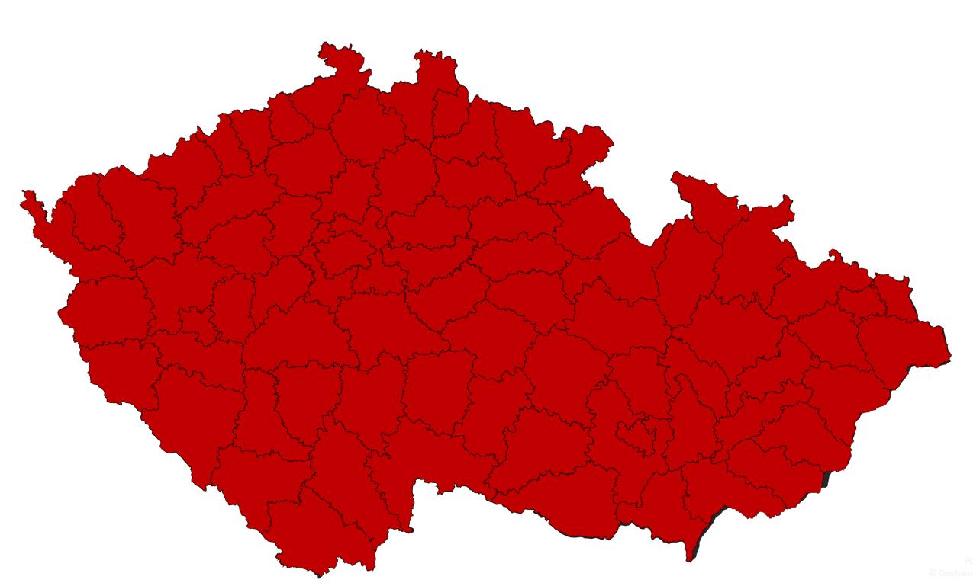
- New restrictive measures are valid from 28 October.

Face Masks
It is mandatory to cover your mouth and nose in following areas:
- all indoor premises except places of residence and accommodation
- schools and educational facilities, including secondary schools and universities
- means of public transport and on stops and platforms
- in outdoor premises if the social distance of 2m cannot be obeyed
Exempt from this rule are children under two years of age and children and teaching staff in nurseries. Further exemptions were introduced and are fully listed on https://koronavirus.mzcr.cz/en/current-measures/

Free movement, gatherings and social contact
- Free movement of people is restricted. The movement should be limited on trips to work, necessary shopping (including shopping for family or community members), urgent official matters and potential visits of doctors. Necessary visits of family members and trips in nature, while maintaining other measures on gatherings, are allowed.
- Both indoor and outdoor events, gatherings and meetings can by attended by a maximum of 2 people. This measure does not apply on:
  - members of one household,
  - persons working together (both employees and entrepreneurs)
- Maximum of 10 persons are allowed to attend weddings, ceremonies on entering civil partnership and funerals.
- Demonstrations can be attended by a maximum of 100 persons in groups of 20. Groups have to maintain social distance between each other.
- Visits of patients in hospitals and clients in social care facilities are prohibited.
- Public drinking of alcoholic beverages is prohibited.

Starting from 28 October, a nationwide curfew is in place between 21:00 – 05:00. This measure is valid for every resident of the Czech Republic with following exemptions:
- Commute to work and other work-related travel
- Necessary activities ensuring
  - Security, order and crisis management,
  - Protection of health and provision of health or social care,
  - Public transport and other infrastructure,
  - Services for residents, including supply and delivery services.
- Urgent trips necessary due to protection of life, health, property or other legally protected interests
- Walking dogs up to 500 meters from the place of residence

Shops and business
- Unessential shops and businesses are closed. The list of essential shops includes grocery shops, drug stores, gas stations, pet shops, news-stands or flower shops.
- Shops and services have to be closed on Sundays and every day between 20:00 – 05:00.
- Groups with maximum of 2 persons can enter shopping malls.
- The wi-fi connection provision in shopping centres above 5 000 m2 is prohibited. Furthermore, measures to prevent gatherings of people inside the shopping mall are to be taken (restricting places to sit, visibly show instructions to keep social distancing etc.).

Furthermore, following events and activities are prohibited
- All cultural events, including concerts, theatres, cinemas, circuses as well as fairs and congresses and other educational events.
- Visits of galleries, museums, castles, chateaus and other historical premises, as well as planetariums and observatories.
- Disco, music and dance clubs and other similar premises.
- Visits of zoos and botanical gardens.

Gastronomy and accommodation services
- All indoor and outdoor premises of catering services are to be closed for public. Exempt from this rule are providers of catering in accommodation, hospitals, institutions of social care and prisons. The catering providers can dispense food to-go via a drive through or walk through windows only between 6 AM – 8 PM.
- Food courts in shopping malls above 5 000m2 are closed.
- All accommodation services are prohibited with following exceptions for:
  - Persons on business trips
  - Persons in isolation or quarantine
  - Person who were already accommodated when this measure was introduced

Education
- Universities and high schools are closed and switched to distance education. Exempt from this measure are healthcare study programmes.
- Primary schools are closed and switched to distance education. This also includes art and language schools and school hobby groups.

Sport
- Operation of indoor sports grounds like fitness centres, gyms, courts, ice rinks etc. is prohibited.
- Operation of swimming pools, aquaparks, wellness centres, saunas and solariums is prohibited.

Mortality
- Case fatality rate in the Czech Republic during the whole pandemic is currently at 0,9 %. After weeks of its steady decrease, the rate is now slowly rising.
As the number of hospitalized patients both in standard ward and ICUs increases in time, the Czech Republic is continuously building backup facilities. The non-urgent operations were pushed forward to ensure sufficient capacities for COVID-19 patients. Furthermore, two new field hospitals to provide additional capacities in Prague and Brno are being constructed.
As of October 29, 40 % of all confirmed cases recovered already, while case fatality rate of 0,9 % is now slowly rising. The case fatality rate of all closed cases is 2,2 %. Even though the Czech Republic is experiencing a steep increase in the number of hospitalized patients, only 3,7 % of active cases are hospitalized and 0,55 % of all active cases are patients in ICUs.
Nearly 70% of the deceased are patients over 75 years of age. Over 90% of the deceased were patients older than 65 years.

Testing
- The trend of daily positive tests shows an increas since the end of August.
- Czech Republic is planning to use antigen tests in specific cases and population groups.
Number of tests being carried out in the Czech Republic is closely connected to the course of the epidemics. It was rising steadily in the beginning, reaching levels around 10 thousand tests a day between the end of March and beginning of June. We have witnessed decrease in testing during the summer months as adopted measures slowed down the progress of epidemics significantly.
Currently, the number of tests is once again increasing. Testing is being carried out throughout the country with the average amount of tests reaching above 40 thousand a day, with maximum of 46 thousand tests on 22 October. As such, the rate of COVID-19 positive patients to number of tests oscillates between 25 – 35 %.

